
INFRA Watch
Infrastructure Network for Fair Reporting and Accountability

Software Design Document (SDD)
Infrastructure Network for Fair Reporting and Accountability

Version | 1.0
Date | October 2026
Prepared by | INFRA Watch Project Team
Institution | Department of Agriculture - Bureau of Agricultural and Fisheries Engineering (DA-BAFE)
Status | Baseline, reflects the implemented system
Companion document | Requirements Analysis Document (RAD)

Table of Contents
1. Introduction 7
1.1 Purpose 7
1.2 Scope 7
1.3 Intended Audience and Use 7
1.4 System Overview 8
System Objectives 8
System Boundaries 8
1.5 References 8
1.6 Relationship to Other Documents 8
1.7 Assumptions and Constraints 8
Assumptions 8
Constraints 9
2. System Overview 10
2.1 System Perspective 10
System Context Diagram 10
2.2 Design Rationale 10
2.3 System Architecture Overview 11
2.3.1 Architectural Layers 11
2.3.2 Component-Level Architecture and Code Layout 12
2.4 Major System Components 13
2.5 Inter-Component Communication 13
2.5.1 Synchronous Communication 13
2.5.2 Asynchronous Communication 13
2.6 Data Flow Overview 14
2.6.1 High-Level Data Flow 14
2.7 Design Constraints and Dependencies 14
2.8 External Interfaces 14
2.9 Performance and Scalability Considerations 15
2.10 Security and Compliance Overview 15
3. Detailed Design 16
3.1 Overview 16
Request Lifecycle 16
Shared Design Rules 16
3.2 Authentication and Access Control Service 16
3.2.1 Purpose 16
3.2.2 Key Modules and Responsibilities 17
3.2.3 Database Entities 17
3.2.4 Data Flow Example: Registration 17
3.2.5 Permission and Scope Logic 17
3.2.6 Security Measures 18
3.3 Project Data Service (ABEMIS Synchronization) 18
3.3.1 Purpose 18
3.3.2 Workflow and Service Flow 18
3.3.3 Key Modules 19
3.3.4 Status Transition Logic 19
3.3.5 Algorithm Overview 19
3.3.6 Integration Points and Failure Handling 20
3.4 Public Portal Query Layer 20
3.4.1 Purpose 20
3.4.2 Key Modules 20
3.4.3 Map and Layers 20
3.4.4 Public-Safe Output 21
3.5 Citizen Engagement Services 21
3.5.1 Feedback Pipeline 21
3.5.2 E-Report Pipeline 21
3.5.3 Upload and Moderation Pipeline 22
3.5.4 Storage Design (MinIO) 22
3.5.5 Comments, Votes, and Moderation of Comments 23
3.5.6 SLA Design 23
3.6 SMS Grievance Service 23
3.6.1 Purpose 23
3.6.2 Key Modules 23
3.6.3 Data Flow 24
3.7 Notification Service 24
3.8 Analytics and Data Quality Services 24
3.9 AI Services 25
3.9.1 Provider Abstraction 25
3.9.2 Public Assistant (ANIA) 25
3.9.3 Knowledge Base 25
3.9.4 MYDAS Dashboard Designer 26
3.9.5 Managerial AI and Voice 26
3.10 Content and Configuration Service 26
3.11 Background Jobs and Scheduler 26
3.12 Audit Service 27
4. Data Design 28
4.1 Overview 28
4.2 Database Architecture 28
4.2.1 Type and Connection 28
4.2.2 Grouping by Domain 28
4.3 Logical Data Model 28
4.4 Physical Data Model 30
4.4.1 Naming and Type Conventions 30
4.5 Key Entities and Attributes 31
4.5.1 Table `projects` 31
4.5.2 Tables `feedback`, `feedback_comments`, `feedback_comment_votes` 31
4.5.3 Tables `issues` and `issue_responses` 32
4.5.4 Tables `user`, `session`, `background_jobs`, `audit_logs` 32
4.5.5 Knowledge, Notification, and Other Tables 32
4.6 ORM and API Integration 33
4.7 Data Integrity and Validation 33
4.8 Indexing, Caching, and Optimization 33
4.9 Migrations, Backup, Archiving, and Retention 34
5. Interface Design 35
5.1 Interface Principles 35
5.2 Error and Success Response Format 35
5.3 Authentication Endpoints 35
5.4 Public Endpoints 36
5.5 Signed-In Citizen Endpoints 36
5.6 Staff Endpoints 37
5.7 Server Actions 38
5.8 External Interface Contracts 38
5.8.1 ABEMIS 38
5.8.2 SMS Gateway and Feed 39
5.8.3 Email 39
5.9 Real-Time Interfaces 39
5.10 Rate Limiting and Request Bounds 39
5.11 Pagination, Filtering, and Sorting 39
5.12 Caching Headers 40
6. Workflow Design 41
6.1 Overview 41
6.2 State Machines 41
6.3 Feedback Workflow 41
6.4 E-Report Workflow 42
6.5 SLA Monitoring and Escalation 42
6.6 SMS Grievance Workflow 42
6.7 Notification Workflow 42
6.8 Knowledge Document Workflow 43
6.9 Account and Live-Video States 43
6.10 Design Constraints 43
7. Security Design 44
7.1 Overview 44
7.2 Security Objectives 44
7.3 Security Architecture Overview 44
7.4 Authentication Design 44
7.4.1 Mechanism 44
7.4.2 Session Management 45
7.5 Authorization and Scope 45
7.5.1 Role, Resource, and Action Model 45
7.5.2 Scope Resolution 45
7.6 Data Protection 45
7.7 Upload Security 45
7.8 Security for Inter-Service and External Interfaces 46
7.9 AI Safety Design 46
7.10 Security Monitoring and Auditing 46
7.11 Privacy and Compliance (RA 10173) 46
7.12 Security Headers and Browser Protections 46
7.13 Summary of Controls and Known Gaps 47
8. Error Handling and Logging 48
8.1 Objectives 48
8.2 Error Taxonomy 48
8.3 Client Error Messages 48
8.4 Logging Design 48
8.5 Audit Entries 49
8.6 Failure Handling by Component 49
8.7 Monitoring and Alerting Recommendations 49
8.8 Example Scenarios 50
Scenario A: ABEMIS returns HTTP 526 at the scheduled hour 50
Scenario B: a citizen uploads a renamed executable as a photo 50
Scenario C: two reviewers reply to the same SMS 50
9. Deployment Design 51
9.1 Topology 51
9.2 Build and Container 51
9.3 Compose and Reverse Proxy 51
9.4 Start-Up Sequence 52
9.5 Configuration 52
9.6 Release Checklist 52
9.7 Backup and Recovery 52
10. Quality and Testing Design 53
10.1 Test Layers 53
10.2 Design for Testability 53
10.3 Acceptance 53
11. Appendices 54
Appendix A. Environment Variable Reference 54
Appendix B. Table Catalog 54
Appendix C. Glossary 56
Appendix D. Change History and Document Control 56

1. Introduction

1.1 Purpose
This Software Design Document (SDD) describes how INFRA Watch is designed and built: its architecture, components, data model, interfaces, workflows, security controls, error handling, and deployment. It is the technical companion to the Requirements Analysis Document (RAD), which states what the system must do.
The design recorded here is the design of the running system, verified against the repository in October 2026. Where the implementation has a known limitation, the limitation is noted beside the design rather than omitted, so that readers can plan around it.
The document is meant to let a new developer:
- Find where each requirement is realised in code, data, and configuration.
- Understand why the main design choices were made and what they cost.
- Change a module without breaking the rules that other modules rely on (scope, audit, public-safe output).
- Deploy, operate, and troubleshoot the system.

1.2 Scope
The SDD covers the whole INFRA Watch application: the public portal, the citizen account area, the staff console, the background jobs, and the integrations with ABEMIS, SMS, email, storage, maps, and AI providers. It does not cover ABEMIS itself, the hosting platform, or the contents of the SMS gateway.
Covered | Not covered
Web application (Next.js), server actions, route handlers | ABEMIS internals; its own RAD and SDD describe it
PostgreSQL schema, migrations, caching, queue | Operating-system, network, and Docker host administration
Integrations as consumed by INFRA Watch | The SMS gateway's and SMTP server's internals
Security, logging, and deployment design | Organizational policy and staffing

1.3 Intended Audience and Use
Audience | Use
Developers | Primary reader. Chapters 3 to 6 are the working reference.
Database administrators | Chapter 4 and Appendix B for schema, indexes, migrations, and backups.
DevOps and system administrators | Chapter 9 for deployment and Appendix A for configuration.
Security reviewers | Chapter 7 and the limitations noted throughout.
QA | Chapter 10 and the workflow rules in Chapter 6.
BAFE technical leads | Chapters 2 and 3 for an overview of how the portal works.

1.4 System Overview

System Objectives
- Present AMEFIP and INS project data from ABEMIS (fiscal years 2021 to 2026) to the public, accurately and with visible freshness.
- Collect citizen feedback, E-Reports, and SMS grievances with verifiable evidence, and route them to the right staff.
- Let BAFE respond within the 72-hour standard and show how well it is doing.
- Give managers scoped analytics and data-quality visibility.
- Protect personal data and make every staff action traceable.

System Boundaries
INFRA Watch is a read model of ABEMIS plus a participation layer. It never writes to ABEMIS and never edits project facts. It owns citizen input, staff decisions, notifications, content, and the audit trail. Figure 1 shows its place among people and external systems.

1.5 References
Reference | Use in this document
RAD for INFRA Watch (companion) | Requirement identifiers FR-* and NFR-* cited throughout
docs/00 to docs/13 and docs/current-system/ | Original design notes and the implemented-feature inventory
docs/erd/ (DBML and Mermaid) | Editable entity-relationship diagram generated from the live schema
lib/db/schema.ts, auth-schema.ts, drizzle/ | Authoritative schema and migrations
docs/reviews/code-security-review-2026-09-27.md | Review findings referenced as limitations
Better Auth, Next.js, Drizzle, PostGIS, MinIO documentation | Framework behavior
RA 10173 (Data Privacy Act); WCAG 2.1 AA; PSGC | Compliance and reference standards

1.6 Relationship to Other Documents
The RAD defines each requirement; this SDD explains the design that satisfies it and cites the identifier. The ERD files and the route inventory are generated or maintained alongside the code and take precedence over any copy in this document if they differ.

1.7 Assumptions and Constraints

Assumptions
- ABEMIS exposes the infrastructure list endpoint with an API key and remains broadly available.
- PostgreSQL, MinIO, nginx, and DNS are provided and backed up outside the application.
- An SMTP relay and an SMS gateway are available for production.
- One application replica is the normal deployment; the design tolerates more with the limitations in Section 2.9.

Constraints
- Project data comes only from ABEMIS, only for fiscal years 2021 to 2026, and is read-only.
- TypeScript on Next.js 16 (App Router) with Better Auth, Drizzle ORM, and PostgreSQL; schema changes only through migrations.
- The container listens on loopback; TLS terminates at nginx.
- Citizen personal data is handled under RA 10173.

2. System Overview

2.1 System Perspective
INFRA Watch is a single deployable web application. It serves four audiences (public visitors, signed-in citizens, staff, and administrators) from one code base, and talks to a small set of external systems. All durable state lives in PostgreSQL and MinIO; the application process holds only caches and live notification connections.

System Context Diagram
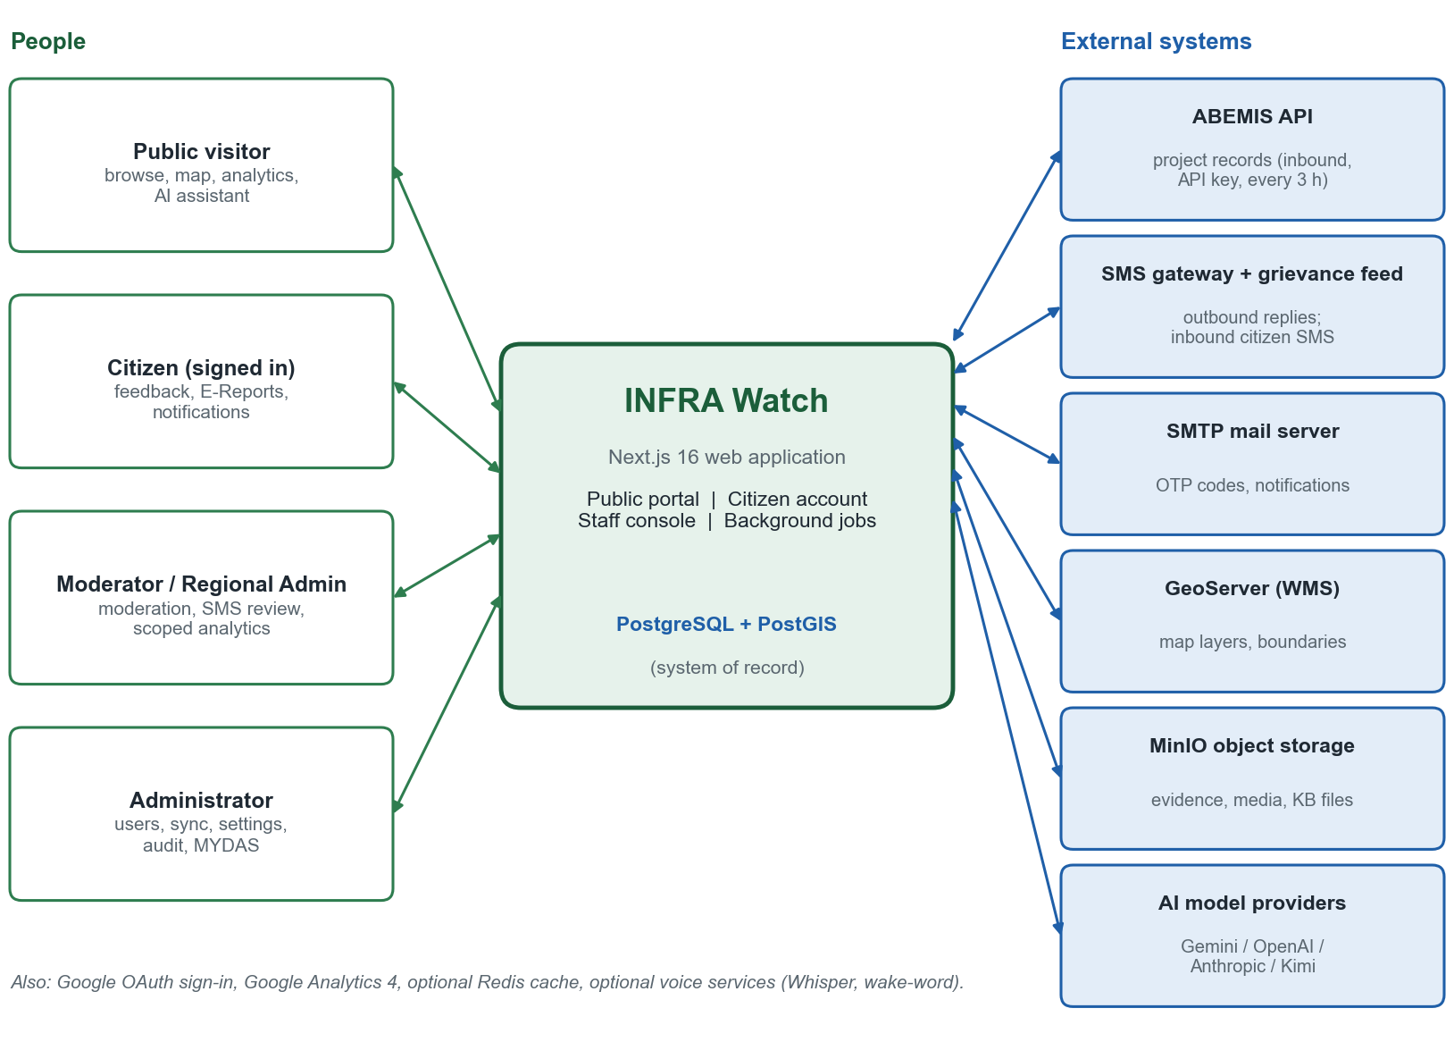
Figure 1. System context: people, the INFRA Watch application, and external systems.

2.2 Design Rationale
The main design decisions, with the reason for each and what it costs:
Decision | Reason | Trade-off
Single Next.js monolith (server components, server actions, route handlers) | One team, one deployment, shared types and validation between browser and server; simple to run on one host | Scaling is vertical first; in-process pieces (live notifications) assume one replica
Read model of ABEMIS in PostgreSQL | Fast public reads, filters, analytics, and PostGIS queries that do not depend on ABEMIS uptime | Data is only as fresh as the last sync; a mapping layer must follow ABEMIS changes
Better Auth with a Drizzle adapter and the admin and access-control plugins | Maintained library for sessions, OTP, OAuth, bans, and role statements | Direct plugin endpoints must be restricted so they cannot bypass app-level scope checks
Declarative permissions in lib/permissions.ts | One reviewable list of resource and action per role | Scope rules (region, program) are separate and must be applied in every query
PostgreSQL job queue with leases instead of an external broker | No extra infrastructure; jobs survive restarts; dedupe and retries are simple SQL | Throughput is modest; polling worker lives in the app process
node-cron inside the app for schedules | Zero extra services; schedules start with the app | Every replica would run the schedule; dedupe keys and 20-hour skip rule contain the effect
Embeddings stored as JSON and ranked in the application | No pgvector dependency; small knowledge base | Linear scan; not suitable for very large corpora
Two MinIO buckets (public media, private evidence and knowledge files) | Public images can be served directly; sensitive files only through authenticated handlers | Start-up must reconcile bucket policies and fail closed
AI through bounded, read-only tools with a refusal policy | Answers grounded in portal data; limited blast radius | The assistant cannot answer anything the tools cannot fetch
Recommendation-only data quality | ABEMIS stays the system of record | Fixes happen elsewhere and arrive on the next sync
Auto-accept setting for feedback and issues (default on) | Citizens see immediate acknowledgment; staff review after the fact | Content is public after automated checks only; staff can switch it off

2.3 System Architecture Overview

2.3.1 Architectural Layers
The system is a layered monolith. Each layer talks only to the one below it. Figure 2 shows the layers and the components in each.
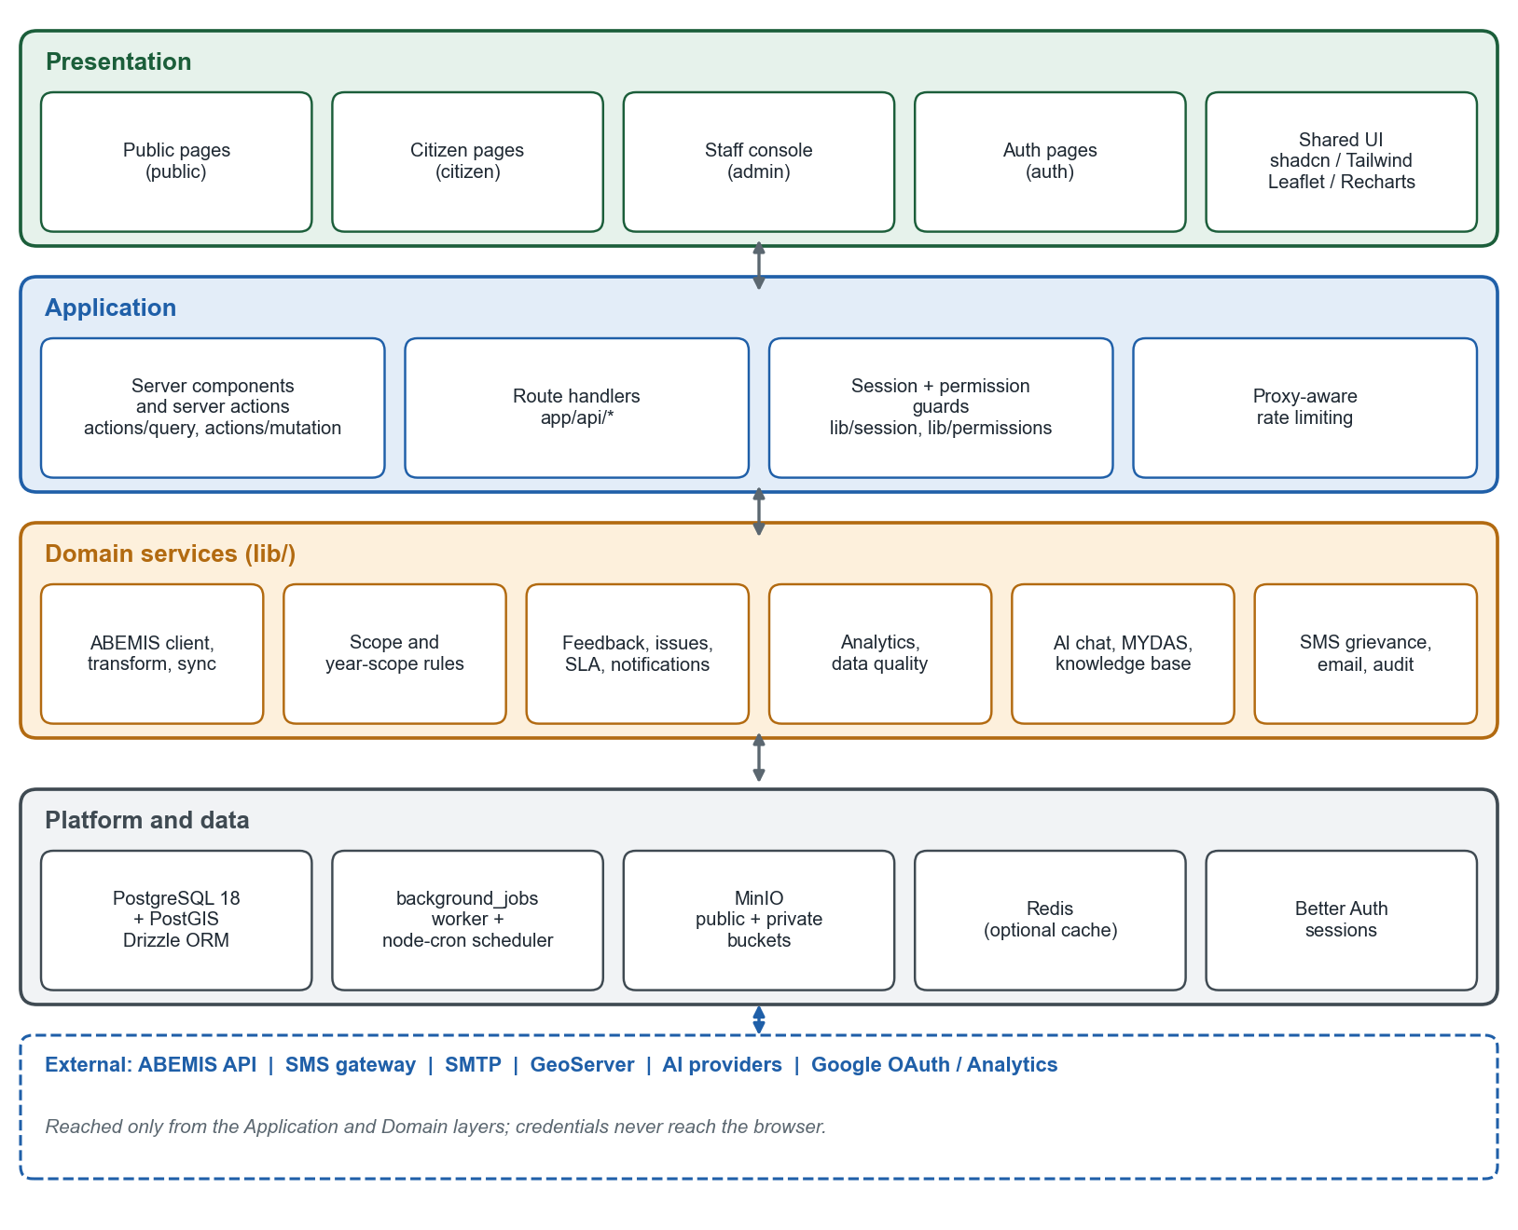
Figure 2. Architectural layers and components.

2.3.2 Component-Level Architecture and Code Layout
Path | Contents
app/(public), (citizen), (auth), (admin), (protected) | Route groups for the four audiences; (admin)/layout.tsx requires a staff role
app/api/* | Route handlers (JSON, uploads, server-sent events, AI, health)
actions/query, actions/mutation | Server actions that read and write data, one file per domain (for example public-projects.query.ts, feedback.mutation.ts)
lib/ | Domain services: abemis/, analytics/, data-quality/, sms-grievance/, mydas/, voice/, public-analytics/, plus auth, scope, audit, cache, minio, scheduler, jobs, notifications, chat, knowledge base
lib/db, auth-schema.ts, drizzle/ | Drizzle schema, connection, and 39 SQL migrations
components/, hooks/, providers/, i18n/ | UI components, client hooks, context providers, translations
constants/, types/ | Stage mapping, program list, shared types and Zod schemas
scripts/, docker/, deploy/ | Migration runner, sync scripts, container start script, nginx sample

2.4 Major System Components
Component | Responsibility | Requirements
Authentication and access | Accounts, OTP, OAuth, sessions, role and permission checks, moderator scope | FR-AUTH-*
Project data service | ABEMIS client, transform, scope filter, upsert, snapshots, location sync | FR-SYNC-*
Public query layer | Directory, record, map, analytics, export with public-safe output and caching | FR-PUB-*
Engagement services | Feedback, comments, votes, E-Reports, uploads, moderation, evidence | FR-FB-, FR-ER-, FR-UP-01, FR-GEO-01
SMS grievance service | Feed intake, review store, replies, auto-link and auto-acknowledge | FR-SMS-01
Notification service | Persistence, live stream, email and SMS delivery, SLA reminders | FR-NOT-*
Analytics and data quality | Managerial dashboard, snapshots, schedule health, findings, engagement events | FR-ADM-01..04, 09
AI services | Chat, knowledge base, managerial AI, MYDAS, voice | FR-AI-*, FR-ADM-02
Content and configuration | Articles, announcements, templates, layers, live videos, settings | FR-PUB-05, FR-ADM-07
Jobs and scheduler | Queue, worker, cron schedules, startup tasks | FR-SYNC-01, FR-NOT-01
Audit and health | Audit log writer and reader, service health | FR-ADM-06, 08

2.5 Inter-Component Communication

2.5.1 Synchronous Communication
- Browser to server: page requests render server components; forms call server actions; client code calls route handlers with JSON or multipart bodies.
- Server to PostgreSQL: Drizzle over a pooled postgres connection (default 10 connections, 20 s idle timeout, 30 min lifetime).
- Server to external services: HTTPS from server code only (ABEMIS, SMS, SMTP, AI providers, MinIO); the browser talks directly only to GeoServer (WMS tiles) and Google Analytics.

2.5.2 Asynchronous Communication
- Job queue: background_jobs rows with kinds abemis-sync, location-sync, media-moderation, and notification-delivery. A worker claims a job with a 2-minute lease, extends it with a heartbeat, retries up to 3 times with exponential back-off (60 s doubling, capped at 15 minutes), and reclaims jobs whose lease expired.
- Cron schedules (Asia/Manila): ABEMIS sync every 3 hours (enqueues a job); chat-history purge 03:15; engagement-analytics maintenance 03:30; SLA reminders every 15 minutes; SMS auto-link and auto-acknowledge every minute.
- Server-sent events: /api/notifications/stream for a signed-in user and /api/admin/jobs/[id]/stream for job progress.

2.6 Data Flow Overview

2.6.1 High-Level Data Flow
- Ingest: ABEMIS to projects (via the sync job), with a run record in sync_logs and a daily row per project in project_metric_snapshots.
- Publish: public pages read projects through query functions that apply the fiscal-year scope and strip non-public fields; frequent reads are cached.
- Participate: a citizen submits feedback or an E-Report; evidence goes to MinIO; the record goes to PostgreSQL; staff and the citizen are notified.
- Respond: scoped staff moderate or respond; every action writes audit_logs; the citizen sees the outcome in their account and, when public, on the portal.
- Measure: SLA reports and the managerial dashboard aggregate the same tables; snapshots give trends.

2.7 Design Constraints and Dependencies
Constraint or dependency | Design consequence
ABEMIS is read-only and sometimes unavailable | Frequent schedule with skip rule; freshness always shown; no write-back
Fiscal-year scope 2021-2026 | One shared condition (projectYearScopeCondition) used in sync and every query
RA 10173 | Anonymity in public DTOs; contact data staff-only; retention limits; deletion pages
Single host, external data services | Application is stateless except caches and live connections; configuration by environment
Better Auth plugin model | Roles and statements declared in one file; app-level guards still required for scope

2.8 External Interfaces
System | Interface summary | Details
ABEMIS | HTTPS GET /api/infra-amefip-list, API key, pages of 500 | Section 5.8.1
SMS gateway and feed | HTTPS POST (send); HTTPS GET (inbound feed) | Section 5.8.2
SMTP | Nodemailer, STARTTLS | Section 5.8.3
MinIO | S3-compatible, two buckets | Section 3.5.4
GeoServer | WMS layers from map_layers; KML proxy | Section 3.4.3
AI providers | Vercel AI SDK; provider chosen by AI_PROVIDER | Section 3.9

2.9 Performance and Scalability Considerations
- Caching: cachedPublic(key, ttl, load) keeps values in a bounded in-process map (at most 100 entries, 30 seconds maximum) and in Redis when configured (TTL per call), de-duplicates concurrent loads, namespaces keys per instance, and can be cleared by an administrator. Public analytics views also send Cache-Control: public, max-age=60, stale-while-revalidate=300.
- Bounded work: admin lists clamp page size to 10 to 100; analytics refuse more than 30,000 rows; chat requests are limited to 64 KB; JSON bodies to 32 KB by default.
- Indexes: project identifier, province, region, status, and funding year; issue status, project, and ticket; feedback status, project, and sentiment; job claim and dedupe.
- Scaling: a second replica works for reads and writes. Two limits apply: live notifications are fanned out in-process (stored history stays complete), and every replica would start the cron schedules (jobs are deduplicated, and the sync skips if a recent success exists).

2.10 Security and Compliance Overview
Security is layered: TLS and header handling at nginx; sessions, roles, and scope in the application; strict validation and moderation of uploads; public-safe output objects; read-only, bounded AI tools; an audit log of staff and security events; and secrets only in the environment. Chapter 7 gives the details. Compliance targets are RA 10173 for personal data and WCAG 2.1 AA for accessibility.

3. Detailed Design

3.1 Overview
This chapter describes each service: its purpose, its main modules, the data it uses, a representative flow, and the safeguards it relies on. All services are modules of one application, not separate processes; "service" means a cohesive group of code under lib/ and actions/.

Request Lifecycle
- The browser sends HTTPS to nginx, which forwards to the application on loopback.
- A page render or action resolves the session (getSession, cached per request) and applies the guard for that area: requireAuth, requireAdminOrModerator, requireAdmin, requireAdminOrRegionalAdmin, or, for APIs, requireStaffApi.
- Mutating staff requests also call assertMutationOrigin; JSON bodies go through jsonBody (content type, origin, and size checks).
- The action calls requirePermission(role, resource, action) and, for project-linked data, adds the scope conditions to its query.
- Input is validated with Zod; the domain function runs against PostgreSQL through Drizzle.
- Significant changes call logAudit; notifications are persisted and queued.
- Output is converted to a public-safe or role-appropriate object; errors go through apiError, which never leaks internals.

Shared Design Rules
- Scope first: any query that touches projects, feedback, or issues for staff includes getProjectScopeConditions(user).
- Public-safe output: public endpoints return purpose-built objects (for example lib/public-issue-dto.ts), never raw rows.
- Audit by default: every staff mutation and security event writes audit_logs.
- Fail closed: unknown role, missing scope, failed policy check, or private-bucket anomaly denies access.
- Explicit unknowns: missing data is returned as unavailable, never as zero or a guess.

3.2 Authentication and Access Control Service

3.2.1 Purpose
Identify the user, hold a session, and decide what the user may do and which projects they may see (FR-AUTH-01 to 06).

3.2.2 Key Modules and Responsibilities
Module | Responsibility
lib/auth.ts | Better Auth instance: Drizzle adapter, email and password with required verification, emailOTP plugin (6 digits, EMAIL_OTP_EXPIRY, sign-up disabled), optional Google provider, admin plugin with role statements, trusted origins, user additional fields (role, region, assignedAgency, phoneNumber, ban fields), bootstrap-admin hook
lib/permissions.ts | Resource and action statements; roles citizen, moderator, regional_admin, admin; hasPermission, requirePermission
lib/session.ts | Cached getSession; guards requireAuth, requireAdmin, requireAdminOrModerator, requireAdminOrRegionalAdmin; canAccessAdmin
lib/scope.ts, lib/moderator-scope.ts | Project scope conditions, checkModeratorScope, assignment normalization
lib/staff-api.ts | requireStaffApi, assertMutationOrigin, jsonBody, apiError for route handlers
lib/auth-otp-email.ts | Delivery of verification and reset codes through SMTP
actions/mutation/users.mutation.ts | Administrator operations on users with self-protection and audit

3.2.3 Database Entities
user, session, account, verification (Better Auth, defined in auth-schema.ts), account_preferences, user_tour_progress, audit_logs.

3.2.4 Data Flow Example: Registration
- The visitor submits name, email, and password on /sign-up.
- Better Auth runs the user.create.before hook, which assigns the role citizen (or admin for a configured bootstrap address), then inserts user and account.
- The OTP plugin creates a 6-digit code in verification and calls sendVerificationOTP; in production deliverAuthCode sends it by SMTP, in development it is logged.
- The visitor enters the code; the user is marked verified and, because autoSignInAfterVerification is on, a session is created.

3.2.5 Permission and Scope Logic
Permissions are looked up in the role's statement list; scope is a query-level filter. Both excerpts are simplified from the code.
// lib/permissions.ts
export function hasPermission(role, resource, action) {
const statements = roleRegistry[role]?.statements;
return Boolean(statements?.[resource]?.includes(action));
}
export function requirePermission(role, resource, action) {
if (!hasPermission(role, resource, action))
throw Object.assign(new Error("You do not have permission..."), { status: 403 });
}

// lib/scope.ts
export function getProjectScopeConditions(user) {
const conditions = [projectYearScopeCondition()]; // always: FY 2021-2026
if (user.role !== "moderator") return conditions; // admin, regional_admin
if (!hasAssignedModeratorScope(user)) return [sql`false`]; // fail closed
if (region) conditions.push(ilike(projects.region, region));
if (agency) conditions.push(eq(projects.program, agency));
return conditions;
}

3.2.6 Security Measures
- Secrets and public URL are mandatory in production; the app throws at start-up without them.
- Origins are limited to a trusted list; staff mutations reject cross-origin requests.
- Bans are enforced by the admin plugin; administrators can end every session of a user.
- Self-protection (no self-ban, self-delete, self-role-change, or self-session-termination) is enforced on the server.
- Known limitation: Better Auth's own administrative endpoints are reachable by authenticated admins and regional admins; the review of 27 September 2026 recommended restricting direct plugin administration so regional-admin region limits cannot be bypassed. Confirm this is applied.

3.3 Project Data Service (ABEMIS Synchronization)

3.3.1 Purpose
Keep the projects read model current and inside scope, and record how the data changes over time (FR-SYNC-01 to 05).

3.3.2 Workflow and Service Flow
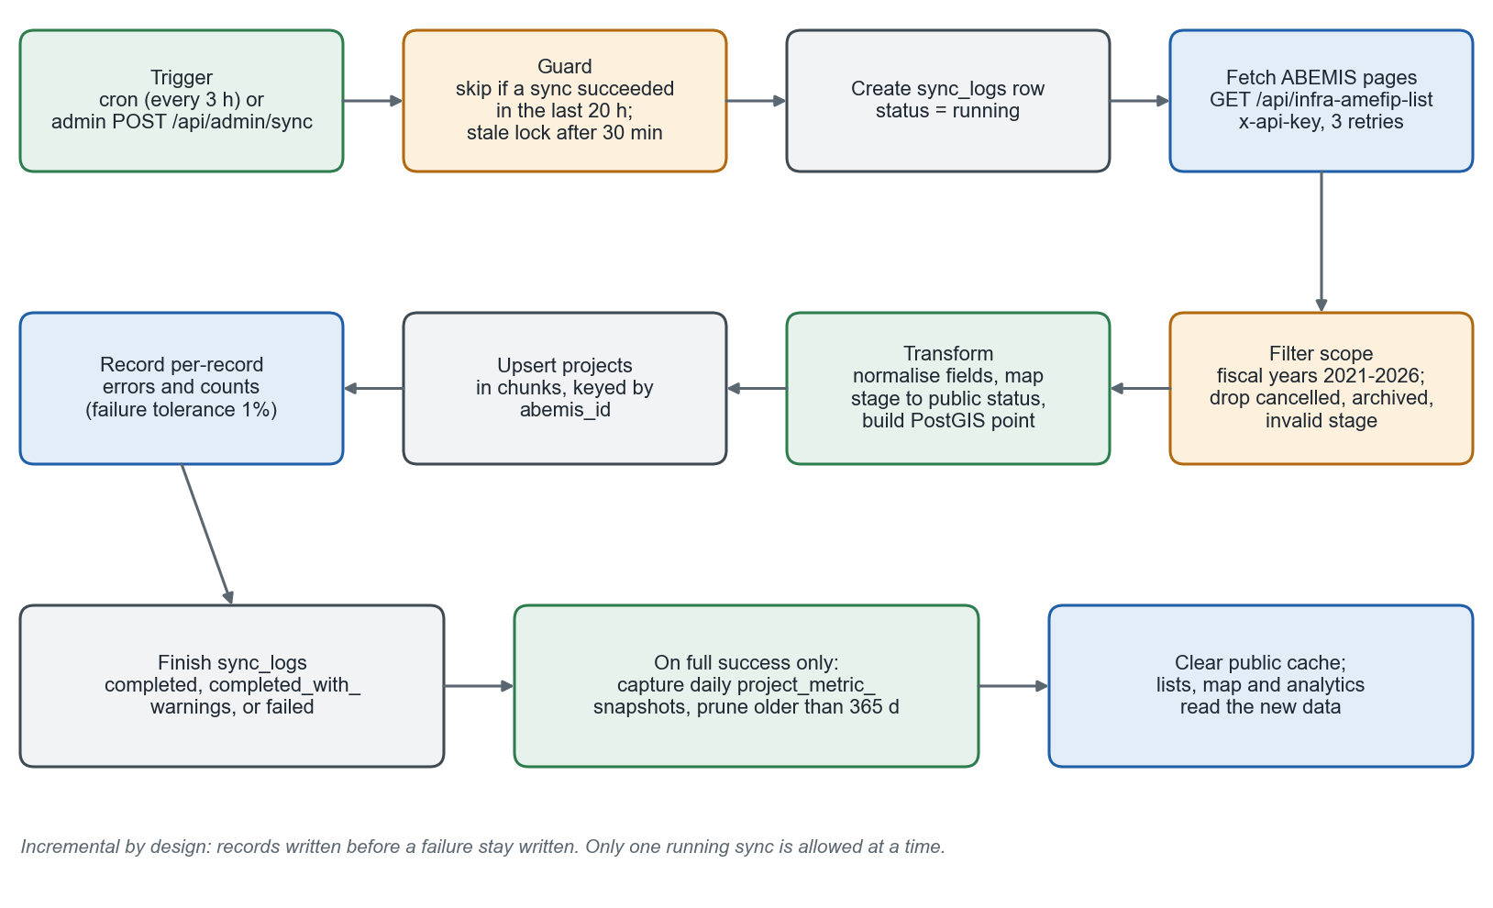
Figure 3. ABEMIS synchronization flow.

3.3.3 Key Modules
Module | Responsibility
lib/scheduler.ts | Cron schedule (default 0 */3 * * *, Asia/Manila) that skips when a sync succeeded recently and otherwise enqueues an abemis-sync job
lib/background-worker.ts | Claims jobs, runs abemis-sync and location-sync, reports progress, marks a run failed if a worker restart interrupted it
lib/abemis/client.ts | fetchInfraProjects with x-api-key, page and page_size, up to 3 retries with back-off; buildUrl keeps requests on the configured origin; redirects are refused
lib/abemis/transform.ts | isInfraWatchProject (project-type filter) and transformAbemisProject (normalizes fields, infers progress, builds location and point)
lib/abemis/year-scope.ts | ABEMIS_SYNC_START_YEAR 2021, ABEMIS_SYNC_END_YEAR 2026, exclusion reasons, projectYearScopeCondition
lib/abemis/sync.ts | Runs a sync: active-run guard, paging (500), scope filter, chunked upsert, per-record error capture, status decision, snapshot capture
lib/analytics/project-metric-snapshots.ts | captureProjectMetricSnapshots, pruneProjectMetricSnapshots (365 days)
constants/stage-mapping.ts | Raw stage to public status mapping

3.3.4 Status Transition Logic
ABEMIS stage text is mapped to three public statuses. Unrecognised text uses a keyword fallback (complete or done gives Completed; ongoing, progress, or an implementation stage that is not "ready" gives On going) and otherwise Not yet started.
ABEMIS stage or status | Public status
Proposal, Pre-implementation, Procurement, Under-Procurement, Planned, Proposal Validated, Implementation-ready, For Review, Incomplete Documents, Not yet started | Not yet started
Implementation, Ongoing, Under-Construction, For Turn-Over, Suspended | On going
Completed, Inventory | Completed

3.3.5 Algorithm Overview
runSync(trigger):
if hasActiveSync(): return // running and younger than 30 min
log = insert sync_logs(status = 'running')
for page in 1..totalPages (page_size 500, retries 3):
for record in page:
reason = getAbemisSyncExclusionReason(record) // year, stage, cancelled, invalid
if reason: counts[reason]++; continue
row = transformAbemisProject(record)
collect row
upsert collected rows in chunks ON CONFLICT (abemis_id)
status = failureRate < 1% ? 'completed_with_warnings' : 'failed' (or 'completed')
update sync_logs(status, counts, errors, duration)
if status == 'completed': captureProjectMetricSnapshots(); prune(365 days)
clearPublicCache()

3.3.6 Integration Points and Failure Handling
Failure | Behavior
ABEMIS returns an error or times out | Retried up to 3 times; the run fails and is logged; the next tick (3 h) tries again
Worker restarts mid-run | The run is marked failed ("will be retried"); the job lease expires and the job is reclaimed
A few records fail | Counted in records_failed; below 1% of processed records the run is completed with warnings
Two runs overlap | Prevented by the active-run guard and the job dedupe key
Source ID corrected upstream | A fallback path may delete and recreate a project when foreign keys block renaming; this can cascade to dependent rows (limitation R-03 in the RAD)

3.4 Public Portal Query Layer

3.4.1 Purpose
Turn the projects read model into fast, safe public pages and APIs (FR-PUB-01 to 07).

3.4.2 Key Modules
Module | Responsibility
actions/query/public-projects.query.ts | getPublicProjects, getPublicMapPins, getPublicMapProjectDetails; fiscal-year scope and public-status filter applied
lib/public-project-directory.ts | Parses and bounds directory state from the URL (search, filters, sort, page)
lib/public-project-record.ts, lib/public-source-media.ts | Builds the project record; sanitizes source media and geotags
lib/public-project-map.ts | Marker model; keeps only coordinates inside Philippine bounds (lib/philippine-coordinates.ts)
lib/public-analytics/* | getPublicProjectSnapshot, filters, VIEW_BUILDERS for /api/public/[view], stage condition shared with sync
actions/query/analytics.query.ts | Portfolio analytics with a 30,000-row ceiling and explicit unavailable state
lib/cache.ts | cachedPublic, clearPublicCache, optional Redis client
lib/project-export.ts | CSV and JSON export of the filtered list

3.4.3 Map and Layers
- Markers come from PostGIS-backed coordinates and are clustered in the browser (react-leaflet-cluster).
- Overlays are rows in map_layers (GeoServer URL, workspace, layer, style, opacity, legend, order); NEXT_PUBLIC_GEOSERVER_URL and workspace are inlined at build time, and an empty URL hides all overlays.
- /api/kml-proxy fetches imported KML for the browser with a 10 MB limit and server-side URL checks.

3.4.4 Public-Safe Output
Public responses are built from allow-listed fields. Source media and geotags pass through a sanitizer; coordinates are dropped when unusable; feedback is limited to approved items; E-Report records pass through public-issue-dto.ts, which removes contact data, internal notes, internal-only responses, and unapproved text.

3.5 Citizen Engagement Services

3.5.1 Feedback Pipeline
- POST /api/projects/[id]/feedback requires a session (401 otherwise) and an existing project (404).
- The comment is trimmed and screened with assertCleanText; the server enforces 1 to 1,000 characters; media references are parsed and must match the portal's own upload paths.
- resolveInitialFeedbackStatus() reads the auto_reply_config setting. If feedback auto-accept is on (the default) the row is inserted as approved; otherwise as pending.
- The row is inserted with userId, rating, category, anonymity flag, and media; an audit record is written.
- Scoped staff are notified; with auto-accept on, the citizen also receives the configured acknowledgment notification from a system actor.
Owners edit or delete their own feedback through PATCH and DELETE on /api/projects/[id]/feedback/[feedbackId]. Staff moderation uses PATCH /api/admin/feedback/[feedbackId]/moderate (approve or reject with an optional note) and DELETE /api/admin/feedback/[feedbackId].

3.5.2 E-Report Pipeline
- POST /api/issues accepts JSON or multipart form data. Required: issue category and a description (at least 20 characters on the JSON path, 10 on the form-data path); identified reports also need a name and contact number.
- Evidence is normalized into a canonical list (type, path, name, optional GPS track) of at most the allowed count; coordinates are validated against latitude and longitude ranges; a geo-video track is bounded in points and time.
- resolveInitialIssueStatus() uses the same auto-accept setting: on gives reviewing with the description copied to the public description (if at least 20 characters) and an automated first response from InfraWatch Automated System; off gives pending.
- A ticket number of the form INFRA-<year>-<six digits> is generated and the row inserted with reporterUserId when a session exists; audit and staff notifications follow.
Staff handling: POST /api/admin/issues/[id]/responses inserts a public or internal response, may change status, may approve the public description, sets resolved_at on resolved, writes audit, and notifies the reporter. Public reads use GET /api/issues and /api/issues/[id] through the public DTO; owners use /api/my-issues.

3.5.3 Upload and Moderation Pipeline
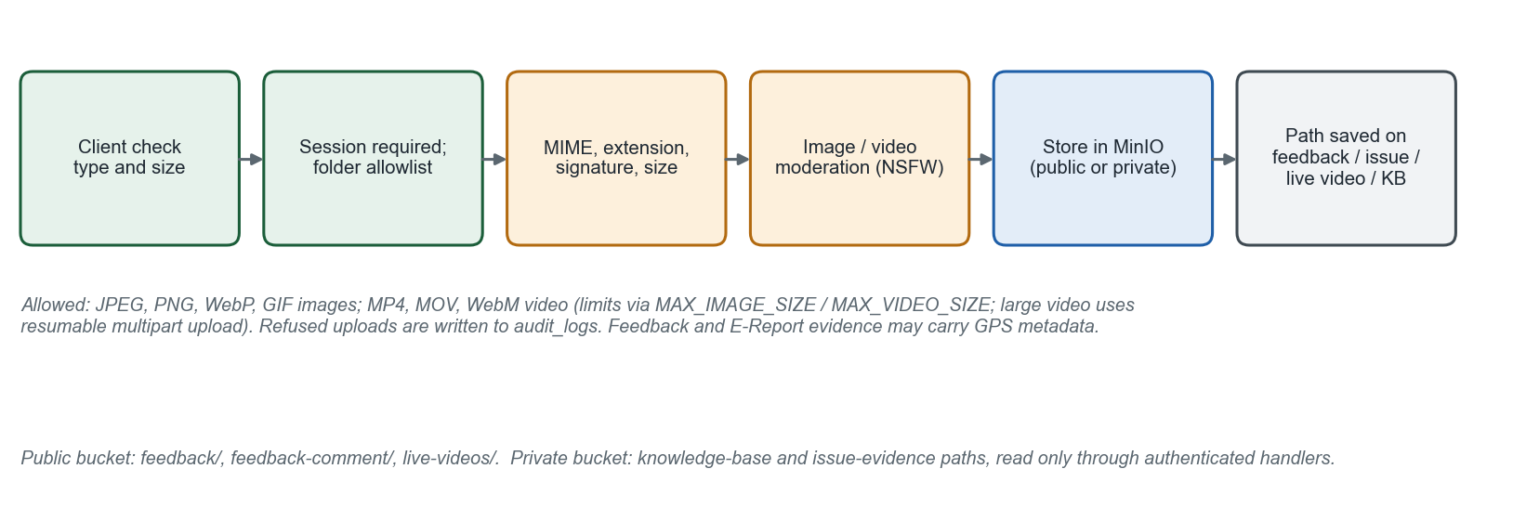
Figure 4. Evidence upload pipeline.
- POST /api/upload?folder=... requires a session and checks the folder against an allowlist (invalid folders are refused and audited).
- The server validates MIME type, extension, file signature, and size; the image type and size limits come from ALLOWED_IMAGE_TYPES, MAX_IMAGE_SIZE, ALLOWED_VIDEO_TYPES, and MAX_VIDEO_SIZE.
- assertSafeImageUpload runs NSFWJS on images (thresholds NSFW_*, optional fail-closed); stored videos are sampled with ffmpeg and each frame is checked (video-moderation.ts).
- Large video uses /api/upload/multipart with 50 MB parts and a resumable upload_sessions record; the limit for a direct upload is 20 GB.
- Previews are served by /api/upload/preview under an image policy that restricts what can be rendered; for private paths the handler first checks who is asking (see Section 3.5.4).
- Issue evidence is private by default. PATCH /api/admin/issues/[id]/evidence/[index] lets staff approve or withdraw a single image for public display, and an image only becomes visible once the issue has a published public summary.

3.5.4 Storage Design (MinIO)
Bucket | Prefixes | Access
Public (MINIO_BUCKET_NAME) | feedback/, feedback-comment/, live-videos/, other approved public media | Anonymous read limited to these prefixes by bucket policy
Private (MINIO_PRIVATE_BUCKET_NAME) | knowledge-base files and issue evidence | No anonymous access; read only through authenticated handlers: /api/upload/preview (knowledge-base readers, or the issue owner, an administrator, or an in-scope moderator for issue evidence), /api/knowledge-base/files/[id], and /api/issues/[id]/public-evidence/[index] for evidence staff approved for public display

At start-up (production only) ensureStorageBuckets creates both buckets, narrows the public bucket policy to the approved prefixes, and refuses to continue if the buckets collide or if the private bucket contains an anonymous Allow. If MinIO cannot be reached during an upload, the code may write to a local .storage directory, which is not durable in a container (limitation R-04).

3.5.5 Comments, Votes, and Moderation of Comments
feedback_comments carries status, auto_rejected, and rejection_reason; text is screened with the same profanity check, and flagged comments are quarantined for the /comment-moderation page (GET and PATCH /api/admin/comments). Votes are one row per user and comment in feedback_comment_votes with a type; counters are kept on the comment.

3.5.6 SLA Design
Constant | Value | Meaning
SLA_BREACH_HOURS | 72 | Agency must report back on action taken (8888 standard)
SLA_GENTLE_REMINDER_HOURS | 24 | Nudge the scoped moderator(s)
SLA_URGENT_REMINDER_HOURS | 60 | Moderators and admins
Breach notice | after 72 | Admins only

runSlaFollowUpReminders runs every 15 minutes and stamps sla_gentle_reminder_at, sla_urgent_reminder_at, and sla_breach_notified_at on issues and feedback. actions/query/reports.query.ts uses the same constants for the SLA reports.

3.6 SMS Grievance Service

3.6.1 Purpose
Give staff a reviewed, auditable path from a citizen's SMS to a project and a reply (FR-SMS-01).

3.6.2 Key Modules
Module | Responsibility
lib/sms-grievance/live-source.ts | Fetches raw messages from SMS_GRIEVANCE_API_URL, validates shape, maps each to an untriaged record in needs_relevance_review
lib/sms-grievance/review-store.ts | Reads and writes sms_grievance_reviews with a version check (optimistic concurrency)
lib/sms-grievance/live-review.ts, policy.ts, issue-management.ts | Overlay of saved decisions on the feed; rules for tagging, out-of-scope, and follow-up linking
lib/sms-grievance/location.ts, categories.ts | Parses coordinates from text; category list shared with the E-Report issue types plus SMS-only categories
lib/sms-grievance/auto-acknowledge.ts | Per-minute jobs: auto-link a sender's new message to their open case (within a week, never sends SMS) and optionally send a first reply
lib/sms.ts | sendSMS: normalizes the number to +639XXXXXXXXX and posts to the gateway
actions/mutation/sms-grievance.mutation.ts | Server actions for tag, out-of-scope, link, and reply; each saves first, then sends

3.6.3 Data Flow
- The review page loads the feed server-side and overlays saved state from sms_grievance_reviews; if the feed is down, labelled synthetic records are shown.
- Staff choose an actual BAFE project from the project read model; parsed text is only a hint.
- The action writes the new state with version + 1; if the stored version differs, the write is rejected so two reviewers cannot send the same reply.
- The SMS is sent after the decision is saved; the thread entry records success or failure. Internal notes are never sent.
The data model keeps the original message text unchanged; project, location, category, responsible office, region, and assignee are separate fields. Limitation: reviews do not yet create issues rows.

3.7 Notification Service
- Persistence: persistNotification inserts one notifications row and one notification_recipients row per user inside a transaction; duplicates are removed.
- Recipients: chosen from project and issue scope (moderators for the region and program, administrators for escalation, the reporter or owner); notificationRecipientsForChannel filters by each user's account_preferences.
- Live delivery: realtime-notifications.ts keeps a registry of open event-stream connections per user in the Node process and writes each new notification to the connected user's stream.
- External delivery: notification-delivery jobs send email (SMTP) and SMS; failed jobs are retried by the queue.
- Read state: POST /api/notifications marks items read; notification_recipients.read_at and notification_reads persist it.
- Templates: email_templates (slug, subject, body, variables, active) edited in /email-templates, with a built-in registry as fallback.

3.8 Analytics and Data Quality Services
Module | Responsibility
lib/analytics/managerial-dashboard-query.ts, dashboard-filters.ts | Strict filter schema; scope and row limits; KPIs, region and funding-year views, priority and delayed projects
schedule-health.ts, completion-forecast.ts, dashboard-changes.ts | Schedule-health classification from dates and progress; forecast; change detection between snapshots
project-metric-snapshots.ts | Daily snapshots used for trends and progress variance
lib/data-quality/project-quality.ts, service.ts | Detects missing, inconsistent, stale, or implausible source fields; paginated findings; export
lib/analytics/citizen-event-*.ts | Privacy-minimal engagement events: policy, rate limit, coarse network-region lookup, store, daily aggregation, retention
actions/query/reports.query.ts | SLA reports for issues and feedback (admin only)
app/api/admin/analytics/* | JSON endpoints for dashboard breakdown, drill-through, progress curve, and cost by region

Design rule: every analytic returns a state (ready, empty, unavailable, or cannot be assessed) with the reason; derived values never silently default to zero. Data-quality findings are read-only by design, and the project PATCH endpoint for data quality returns 405.

3.9 AI Services

3.9.1 Provider Abstraction
lib/ai-provider.ts maps AI_PROVIDER to a model through the Vercel AI SDK: Google Gemini (default, gemini-flash-latest), OpenAI (gpt-4o-mini), Anthropic, or Kimi. AI_MODEL overrides the model. All AI features use this one function, so provider changes are a configuration change.

3.9.2 Public Assistant (ANIA)
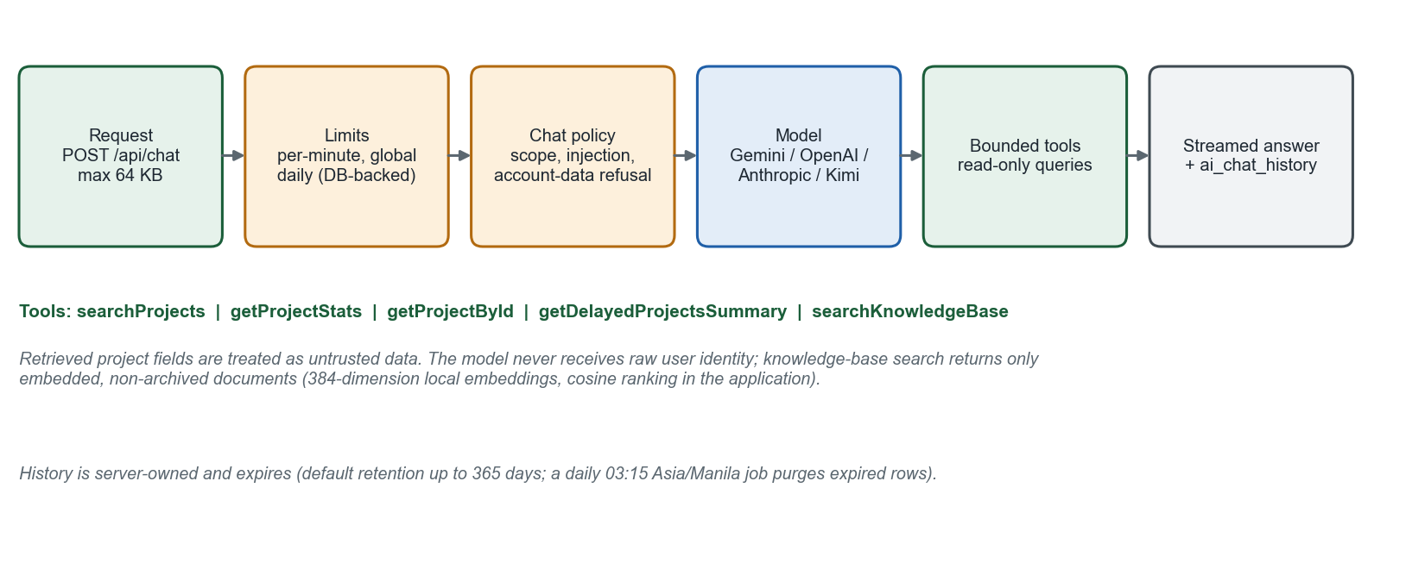
Figure 5. Public assistant request flow.
Module | Responsibility
app/api/chat/route.ts | Orchestrates the request; builds the system prompt including the scope instruction and the fixed list of suggested next-step keys
lib/chat-request.ts | Limits: 64 KB body, 20 history messages, 4,000 characters per message, 20,000 characters of history
lib/chat-policy.ts | Refuses unrelated or coding requests, attempts to reveal internals or user data, and prompt-injection phrases
lib/chat-rate-limit.ts | Per-identity per-minute limit (default 5, configurable 1 to 100) and global daily limit (default 2,000) stored in ai_chat_rate_limits; identity is hashed
lib/chat-tools.ts | Five read-only tools: searchProjects, getProjectStats, getProjectById, getDelayedProjectsSummary, searchKnowledgeBase
lib/chat-history.ts, chat-history-*.ts | Server-owned history with owner key, status, token counts, expiry, and daily purge
lib/chat-grounding.ts, chat-links.ts, chat-actions.ts | Grounding checks; safe links and action targets limited to known keys

3.9.3 Knowledge Base
- Upload or FAQ entry: staff upload PDF, TXT, or Markdown, or type a question and answer; the file goes to the private bucket and a kb_documents row is created.
- Extract: kb-extractor.ts reads PDF (pdf-parse), TXT, or Markdown, normalizes Unicode and whitespace, and rejects empty text.
- Chunk: kb-chunker.ts splits text (defaults KB_CHUNK_SIZE 500, KB_CHUNK_OVERLAP 50).
- Embed: kb-embedding.ts runs the all-MiniLM-L6-v2 model locally (Transformers.js), producing 384-dimension normalized vectors.
- Store: chunks are written to kb_chunks.embedding as JSON, in a transaction that swaps old chunks for new ones when reindexing.
- Search: kb-search.ts embeds the query, loads active chunks of embedded documents, and ranks them by cosine similarity in the application.

3.9.4 MYDAS Dashboard Designer
MYDAS (admin only) turns a plain-language question into a chart. The model proposes a query and a display type from analytics-catalog.ts; sql-guardrails.ts then enforces: one statement; no comments; must start with SELECT; forbidden keywords (data-changing, administrative, file, and INTO or WITH constructs); only the tables projects, feedback, issues, contact_messages; a row limit (default 500, maximum 1,000); and execution inside a transaction with statement_timeout of 5 seconds. The prompt only describes selected columns, but the validator limits tables, not columns, so access stays admin-only.

3.9.5 Managerial AI and Voice
- Managerial copilot and executive brief (ENABLE_MANAGERIAL_AI=true): managerial-ai-policy.ts, managerial-ai-prompt.ts, and managerial-ai-tools.ts bound the context to the user's authorized dashboard scope; output keeps its verification notice.
- Voice (VOICE_ASSISTANT_ENABLED): /api/voice/wake-token issues a signed token (WAKE_WORD_TOKEN_SECRET); /api/voice/transcribe forwards bounded audio to a private Whisper-compatible service (LOCAL_WHISPER_URL); speech is synthesized in the browser with Kokoro or a browser fallback.

3.10 Content and Configuration Service
lib/content-management.ts and actions/mutation/content.mutation.ts manage articles, announcements, email templates, and map layers; live-videos.mutation.ts manages broadcasts inside a transaction that guarantees at most one live and one featured entry; settings.mutation.ts writes system_settings. Settings include auto_reply_config (auto-accept toggles and messages), maintenance_mode, and public_banner. While maintenance mode is on, the public sees a notice and staff (admin, regional admin, moderator) keep access; /sign-in and /forget-password stay reachable.

3.11 Background Jobs and Scheduler
Task | Trigger | Mechanism | Function
ABEMIS sync | Cron every 3 h; manual | Queue job abemis-sync | Refresh projects and snapshots
Location sync | Manual | Queue job location-sync | Refresh PSGC locations
Media moderation | On demand | Queue job media-moderation | Check stored media
Notification delivery | On event | Queue job notification-delivery | Email and SMS
Chat history purge | Daily 03:15 | Cron | Delete expired chat rows
Engagement maintenance | Daily 03:30 | Cron | Prune and aggregate engagement events
SLA reminders | Every 15 min | Cron | Gentle, urgent, and breach notices
SMS auto-link and acknowledge | Every minute | Cron (no-op unless configured) | Link follow-ups; first SMS reply
Upload clean-up | Periodic in worker | Worker | Remove expired upload sessions

The scheduler starts when ENABLE_SCHEDULER=true, or in production unless ENABLE_SCHEDULER=false. The worker starts in production unless ENABLE_BACKGROUND_WORKER=false, and in development only when it is true. In production the storage policy reconciliation completes before the scheduler starts. An administrator can list jobs, enqueue an abemis-sync or location-sync job (HTTP 202), and retry a failed one through /api/admin/jobs.

3.12 Audit Service
lib/audit.ts writes audit_logs (table, record, action, user, old and new values, changed fields, IP address, user agent, notes). ensureAuditLogsTable creates the table on demand; getAuditContextFromRequest extracts actor and network details. Writers are called after the business operation and must not make it fail. Reads are served by actions/query/audit-logs.query.ts and /api/audit-logs with filters by group, action, category, date, and text.

4. Data Design

4.1 Overview
All durable structured data is in one PostgreSQL 18 database, infra_watch, with the PostGIS extension. Files are in MinIO. The database has 44 base tables, 16 enforced foreign keys, and 73 secondary indexes. Schema is defined in TypeScript with Drizzle and changed by SQL migrations.

4.2 Database Architecture

4.2.1 Type and Connection
- Relational with jsonb for flexible payloads and PostGIS for spatial data.
- Driver postgres (postgres.js) through Drizzle (drizzle-orm/postgres-js); one pool per process, size DATABASE_POOL_MAX (default 10), idle timeout 20 s, maximum lifetime 1,800 s.
- Extensions installed: plpgsql, postgis. Embeddings are plain JSON, so pgvector is not required.
- Production refuses to start without DATABASE_URL.

4.2.2 Grouping by Domain
Domain | Tables
Identity | user, session, account, verification, account_preferences, user_tour_progress
Project mirror and reference | projects, sync_logs, project_metric_snapshots, project_data_corrections, project_commodity_overrides, psgc_locations, regional_statistics, map_layers
Engagement | feedback, feedback_comments, feedback_comment_votes, issues, issue_responses, sms_grievance_reviews, contact_messages, contact_responses, saved_posts, post_subscriptions, submission_surveys
Notifications | notifications, notification_recipients, notification_reads
Content | articles, announcements, live_videos, email_templates, system_settings
AI | ai_chat_history, ai_chat_rate_limits, kb_documents, kb_chunks, mydas_dashboards
Operations | audit_logs, background_jobs, upload_sessions, analytics_events, analytics_daily_aggregates
Platform | spatial_ref_sys (PostGIS)

4.3 Logical Data Model
Figures 6 and 7 show the entities and enforced relationships. The editable DBML and Mermaid files in docs/erd/ contain every table and column and can be regenerated from the live database with node docs/erd/generate-erd.cjs.
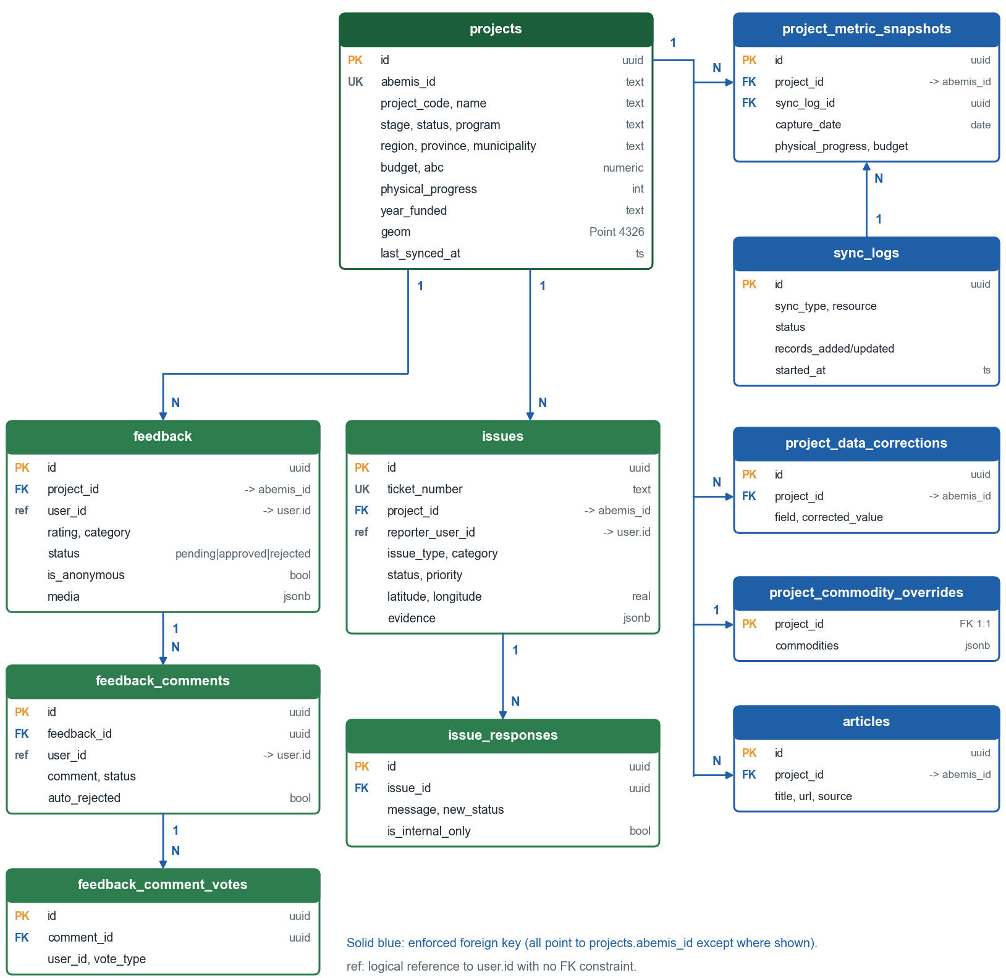
Figure 6. Logical model: projects, engagement, and synchronization.
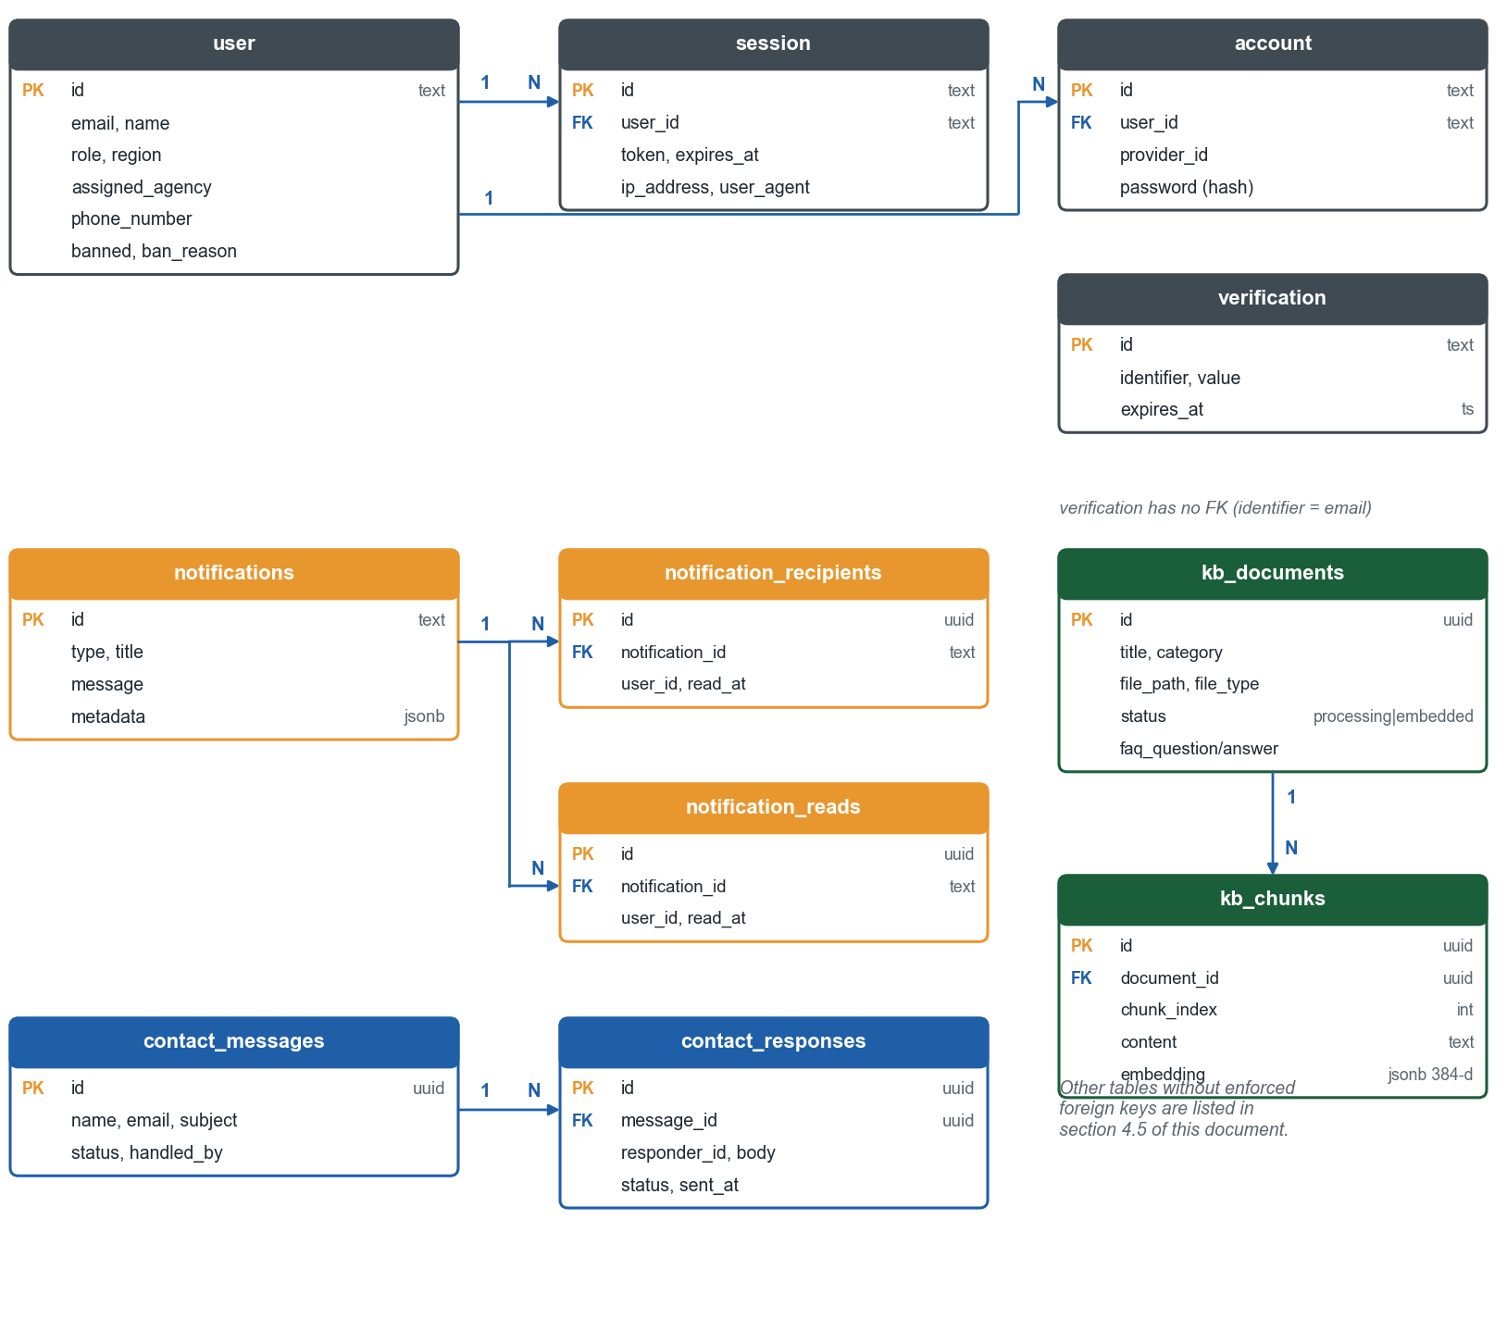
Figure 7. Logical model: identity, notifications, knowledge base, and contact.

4.4 Physical Data Model

4.4.1 Naming and Type Conventions
- Table and column names are snake_case; tables are plural (projects, issues) except Better Auth's own (user, session, account, verification).
- Primary keys are uuid with gen_random_uuid() for application tables and text for Better Auth tables.
- Timestamps are timestamp (or timestamptz for jobs); created_at defaults to now(); updated_at is set by the application.
- Money is numeric(14,2); coordinates are real plus a geometry(Point,4326); status values are plain text validated in code.
- Foreign keys to projects reference projects.abemis_id, the stable source key.

4.5 Key Entities and Attributes

4.5.1 Table `projects`
Column group | Columns | Notes
Keys | id (uuid, PK), abemis_id (unique), abemis_raw_id (unique), project_code | abemis_id is the join key for children
Description | name, description, project_type, program, sub_program, banner_program, prexc_program, indicator_level1, indicator_level3, farm_operation, recipient_type, beneficiary | program is AMEFIP or INS
Place | region, province, municipality, barangay, district, psgc_code, latitude, longitude, geom | geom is PostGIS Point 4326
Money | budget, abc, contract_amount, budget_process, procurement_mode | numeric(14,2)
Progress and time | status, stage, physical_progress, financial_progress, calendar_days, start_date, target_completion_date, actual_completion_date, date_turn_over | progress 0 to 100
Delivery detail | contractor_name, implementing_agency, operating_unit, year_funded, quantity, quantity_unit, proposed_length, post_geotagged_length, road_*, implementation_type | text
Raw and audit | metadata (jsonb), commodities (jsonb), author, last_synced_at, created_at, updated_at | metadata keeps source detail

Indexes: projects_abemis_id_idx, projects_province_idx, projects_region_idx, projects_status_idx, projects_year_funded_idx.

4.5.2 Tables `feedback`, `feedback_comments`, `feedback_comment_votes`
Column | Type | Description
feedback.id | uuid PK | Identifier
project_id | text FK | References projects.abemis_id (cascade)
user_id | text | Author (logical reference to user.id)
rating, category, comment | int, text, text | 1 to 5 rating; general, quality, progress, concerns
media | jsonb | List of portal-hosted images and videos
is_anonymous | boolean | Hides the author on public pages only
status | text | pending, approved, rejected
moderated_by, moderated_at, moderation_note | text, timestamp, text | Decision record
sla_*_at, auto_acknowledged_at | timestamp | Reminder checkpoints
sentiment, issue_type, helpful_count | text, text, int | Classification and counters
feedback_comments.* | uuid PK; FK feedback_id | comment, media, status, auto_rejected, rejection_reason, vote counts, moderation fields
feedback_comment_votes.* | uuid PK; FK comment_id | user_id, vote_type

4.5.3 Tables `issues` and `issue_responses`
Column | Type | Description
issues.id, ticket_number | uuid PK, text unique | Identifier and public ticket
project_id | text FK | Optional link to projects.abemis_id (set null)
reporter_user_id, reporter_name, reporter_contact, reporter_email, is_anonymous | text, boolean | Reporter identity; staff only
category, issue_type, reported_project_type, reported_farm_operation | text | Classification
status, priority | text | pending, reviewing, resolved, closed; priority default normal
description, public_description, public_approved_at, public_approved_by | text, timestamp | Private text and approved public text
region, province, municipality, barangay, landmark, latitude, longitude | text, real | Location
evidence, geo_video_track, geo_video_url | jsonb, jsonb, text | Evidence list and geo-video track
assigned_to, resolved_at, sla_*_at | text, timestamp | Handling and SLA checkpoints
issue_responses.* | uuid PK; FK issue_id (cascade) | responder_*, message, status_change, new_status, internal_notes, is_internal_only, attachment_urls

4.5.4 Tables `user`, `session`, `background_jobs`, `audit_logs`
Table | Notable columns
user | id (text PK), email (unique), email_verified, role (default citizen), region, assigned_agency, phone_number, banned, ban_reason, ban_expires
session | id, token, user_id (FK, cascade), expires_at, ip_address, user_agent, impersonated_by
background_jobs | kind, status (default queued), dedupe_key (partial unique index while active), payload, progress, result, attempts, max_attempts (3), available_at, lease_until, lease_token, error
audit_logs | table_name, record_id, action, user_id, user_name, old_values, new_values, changed_fields, ip_address, user_agent, notes, created_at

4.5.5 Knowledge, Notification, and Other Tables
Table | Notable columns
kb_documents | title, category, file_type, file_name, file_path, file_size, chunk_count, status, faq_question, faq_answer, content_preview, error_message, uploaded_by
kb_chunks | document_id (FK, cascade), chunk_index, content, embedding (jsonb, 384 numbers), token_count
notifications, notification_recipients | type, title, message, metadata; recipient user_id, read_at
sync_logs | sync_type, resource, status, records_added, records_updated, records_failed, total_processed, errors, error_details, started_at, completed_at, duration, triggered_by
project_metric_snapshots | project_id, sync_log_id, capture_date, physical_progress, financial_progress, budget, abc, status, target_completion_date, program
ai_chat_history | conversation_id, user_id, user_message, assistant_message, status, provider, model, tool_names, token counts, duration_ms, finish_reason

4.6 ORM and API Integration
Queries are written with Drizzle's query builder. The schema modules export typed tables, and query functions compose conditions, including the scope conditions from Section 3.2.5.
// lib/db/index.ts (excerpt)
const sql = postgres(databaseUrl, {
max: Number(process.env.DATABASE_POOL_MAX ?? 10),
idle_timeout: Number(process.env.DATABASE_IDLE_TIMEOUT ?? 20),
max_lifetime: Number(process.env.DATABASE_MAX_LIFETIME ?? 1800),
});
export const db = drizzle(sql, { schema: { ...schema, ...authSchema } });

// typical scoped query
const rows = await db.select().from(projects)
.where(and(...getProjectScopeConditions(user), ilike(projects.name, `%${q}%`)))
.orderBy(sql`last_synced_at desc`).limit(pageSize).offset(offset);

4.7 Data Integrity and Validation
Layer | Mechanism
Database | Primary and unique keys; 16 foreign keys with explicit delete rules; partial unique index for active jobs; not-null defaults on timestamps
Application | Zod schemas at every boundary; typed Drizzle inserts; status constants; normalization helpers
Files | Path pattern checks (feedback/<ts>-<hex>.<ext>), MIME and signature checks, folder allowlists
Concurrency | Row version in sms_grievance_reviews; job leases with fencing token; transactions for notification persistence, live-video state, and knowledge reindex swaps

4.8 Indexing, Caching, and Optimization
- Indexes support the filters and joins used by pages: projects (id, province, region, status, year), issues (status, project, ticket), feedback (status, project, sentiment), kb_chunks (document and chunk), background_jobs (claim and dedupe), analytics tables (date and metric).
- Public reads use cachedPublic; admin-visible cache clear is audited.
- Analytics use bounded row counts and fetch only needed columns; snapshots avoid recomputing history.
- Spatial queries use the PostGIS point column; the browser clusters markers.

4.9 Migrations, Backup, Archiving, and Retention
- Migrations: 39 SQL files in drizzle/ with a journal. At container start scripts/prepare-migrations.ts prepares the journal and scripts/migrate.mjs applies pending files one statement at a time, treating "already exists" as a no-op; it replaces drizzle-kit migrate, which could roll back an entire run on a Postgres notice under Bun. RUN_DB_MIGRATIONS=false skips this step. BASELINE_EXISTING_DATABASE=true is a one-time opt-in for a database that predates the journal.
- Rollback: reverse SQL for selected migrations is kept in docs/migrations/.
- Backup: database and bucket backups are an operational task outside the application; schedule them and test restores.
- Retention: see RAD Section 4.7 (chat history up to 365 days, snapshots 365 days, analytics events pruned, audit log kept until an administrator removes entries).

5. Interface Design

5.1 Interface Principles
- Server actions first. Pages and forms use server actions (actions/query, actions/mutation). Route handlers exist where a browser, an external system, a stream, or a file transfer needs an HTTP endpoint.
- JSON over HTTPS. Bodies are application/json unless a route accepts multipart uploads. Staff JSON bodies are limited to 32 KB by default and must declare the content type.
- Session cookies. Authentication is a Better Auth session cookie; there are no API keys for users.
- Origin checks. Mutating staff endpoints reject a mismatching Origin header.
- No version prefix. Routes are unversioned (/api/...) because the only API client is this application; breaking changes are made together with the pages that call them.
- Public-safe by construction. Public routes return purpose-built objects, never raw rows.

5.2 Error and Success Response Format
Two response conventions exist, matching the two kinds of endpoint:
Endpoint family | Success | Error
Staff and operational routes (/api/admin/*, /api/health, jobs, sync) | Plain JSON object or list; HTTP 200, 201, or 202 | { "error": "message" } with 400, 401, 403, 404, 413, 415, or 5xx; produced by apiError
Participation routes (feedback, issues, uploads) | { "success": true, "data": {...}, "message": "..." }, HTTP 201 on create | { "success": false, "error": "message" } with the matching status
Public analytics (/api/public/[view]) | { "data": ..., "dataAsOf": "<ISO>", "filters": {...} } | { "error": "..." }, 404 for unknown view, 503 when project data is unavailable

apiError maps Zod validation errors to 400 with the issue messages joined, uses the error's status for known conditions, and replaces any 5xx detail with "Service unavailable. Try again." so internals are never exposed. Server errors are logged by name only.

5.3 Authentication Endpoints
Method | Route | Access | Purpose
GET, POST | /api/auth/[...all] | Public (rate and origin rules by Better Auth) | Sign-up, sign-in, sign-out, email OTP, password reset, OAuth callbacks, session lookup, admin plugin operations

5.4 Public Endpoints
Method | Route | Purpose
GET | /api/projects, /api/projects/[id] | Project list and detail
GET | /api/public/projects, /api/public/projects/[id] | Public-safe project list and detail
GET | /api/public/[view] | Analytics views over a cached project snapshot (places search and named views); Cache-Control: public, max-age=60, stale-while-revalidate=300
GET | /api/public/project-export | Filtered project export; format=csv returns infrawatch-projects.csv
GET | /api/public/regional-statistics | Regional statistics for a year and program, cached 60 s
GET | /api/public/articles, /api/public/site-notices, /api/announcements/active | Articles, maintenance and banner notices, active announcements
GET | /api/map-layers, /api/kml-proxy | Overlay definitions; bounded KML fetch
GET | /api/evidence | Public-safe geolocated evidence
GET, POST | /api/issues | Public E-Report list; create an E-Report
GET | /api/issues/[id], /api/issues/[id]/public-evidence/[index] | Public-safe or owner-aware detail; approved evidence image
GET | /api/projects/[id]/feedback | Approved feedback for a project
POST | /api/analytics/events | Privacy-minimal usage event, rate limited
POST | /api/chat | Public assistant (streamed)

5.5 Signed-In Citizen Endpoints
Method | Route | Purpose
POST | /api/projects/[id]/feedback | Submit feedback
PATCH, DELETE | /api/projects/[id]/feedback/[feedbackId] | Owner edits or deletes own feedback
GET | /api/my-feedbacks, /api/my-issues | Owner lists
GET, POST | /api/notifications | List notifications; mark read
GET | /api/notifications/stream | Server-sent events for live notifications
POST | /api/upload | Validated upload
GET, POST, PUT, DELETE | /api/upload/multipart | Resumable multipart upload for large video
GET | /api/upload/preview | Authorized preview of stored media
POST | /api/submission-survey; GET /api/submission-survey/status | Optional survey and gate status

Example: submit feedback.
POST /api/projects/{id-or-code}/feedback
{ "comment": "The canal lining is cracked near the pump house.",
"category": "concerns", "issueType": "irrigation_leak", "rating": 2,
"isAnonymous": true,
"media": [ { "type": "image", "url": "feedback/1760000000000-<32 hex>.jpg" } ] }

201 { "success": true,
"data": { "id": "...", "status": "approved", "unhelpfulCount": 0, "commentCount": 0 },
"message": "Feedback submitted and approved automatically. It's now visible on the project page." }
400 { "success": false, "error": "Comment must be 1000 characters or less" }
401 { "success": false, "error": "Authentication required" }

Example: submit an E-Report (form data). Fields: projectId (optional), category, description, isAnonymous, reporterName, reporterContact, reporterEmail, region, province, municipality, barangay, landmark, and evidence files. The JSON path accepts a canonical evidence array with coordinates and a geo-video track instead of files. On success the response is HTTP 201 with the created record and the message "Issue report submitted. Tracking ticket INFRA-<year>-<six digits> has been created."

5.6 Staff Endpoints
Method | Route | Access | Purpose
GET | /api/admin/analytics, /breakdown, /drillthrough, /progress-curve, /cost-by-region | Staff, analytics view | Managerial dashboard data (scoped)
POST | /api/admin/analytics/assistant | Staff, managerial AI enabled | Copilot and executive brief
GET | /api/admin/citizen-engagement | Staff | Engagement analytics
GET | /api/admin/projects, /api/admin/projects/stats | Staff (scoped) | Admin project list and statistics
DELETE, PATCH | /api/admin/projects/[id]/commodities | Staff | Commodity override
GET | /api/admin/feedback, /stats | Staff (scoped) | Feedback queue and counts
PATCH | /api/admin/feedback/[feedbackId]/moderate | Staff (scoped) | Approve or reject
DELETE | /api/admin/feedback/[feedbackId] | Staff (scoped) | Delete feedback
GET, PATCH | /api/admin/comments | Staff | Comment moderation list and decision
GET | /api/admin/issues, /stats | Staff (scoped) | E-Report queue and counts
GET, DELETE | /api/admin/issues/[id] | Staff (scoped) | Detail; delete
POST | /api/admin/issues/[id]/responses | Staff (scoped) | Response and status change
PATCH | /api/admin/issues/[id]/evidence/[index] | Staff (scoped) | Approve or withdraw one image for public display
GET | /api/admin/sms-grievance/attention | Staff | Count of SMS items needing attention
GET | /api/admin/data-quality, /export | Staff | Findings and export
PATCH | /api/admin/data-quality/projects/[projectId] | Staff | Always returns 405 (recommendation-only)
GET, POST | /api/admin/sync | Staff view; admin trigger | Sync statistics; start a sync
GET | /api/admin/sync-logs | Staff | Sync history
GET, POST, PATCH | /api/admin/jobs; GET /api/admin/jobs/[id]/stream | Admin | List, enqueue, retry; job progress stream
GET | /api/admin/locations | Staff | Location options
GET, PUT, DELETE | /api/admin/regional-statistics | Staff | Regional statistics maintenance
GET | /api/admin/chat-history | Staff (role-based visibility) | Assistant history
GET | /api/audit-logs | Staff, audit view | Audit entries
GET, DELETE | /api/health | Admin | Service health; clear public cache
POST | /api/knowledge-base/upload, /process; GET /files/[id] | Staff, knowledge-base permissions | Upload, index, download
POST | /api/voice/wake-token, /api/voice/transcribe | Admin | Voice assistant support

5.7 Server Actions
Each file groups the actions of one domain. Queries are read-only and cached per request where useful; mutations validate input, check permission and scope, write audit, and call revalidatePath for the pages affected.
Group | Files
Queries | public-projects, project-preview, analytics, activity-feed, community-stats, feedback, feedback-comments, feedback-votes, issues, reports, audit-logs, users, settings, knowledge-base, live-videos, contact-messages, get-location-options, mydas-dashboard (each *.query.ts)
Mutations | auth, feedback, feedback-comment, feedback-vote, post-interactions, profile, contact, suggestion, content, email-templates, knowledge-base, live-videos, settings, sms-grievance, users, mydas, mydas-dashboard (each *.mutation.ts)

5.8 External Interface Contracts

5.8.1 ABEMIS
GET {ABEMIS_BASE_URL}/api/infra-amefip-list?page=1&page_size=500[&year_funded=2025]
x-api-key: <ABEMIS_API_KEY>

200 { "data": [ { ...project... } ], "pagination": { "total_pages": N, ... } }

The client retries up to three times with a delay that grows each time, refuses redirects, and refuses a target on a different origin from ABEMIS_BASE_URL. The endpoint path can be overridden with ABEMIS_INFRA_ENDPOINT but must be root-relative.

5.8.2 SMS Gateway and Feed
Outbound: POST {SMS_API_URL} with a JSON body containing the sender identifier, account username and password from the environment, the recipient normalized to +639XXXXXXXXX, and the message; the function returns { success, error?, data?, status? } and never throws. Inbound: GET {SMS_GRIEVANCE_API_URL} returns { messages: [...] } where each message has an identifier, SMS identifier, sender number, content, receive date and time, location, status, month, and year; records failing the shape check are ignored.

5.8.3 Email
sendEmail({ to, subject, text, html }) uses Nodemailer with MAIL_HOST, MAIL_PORT (default 587), credentials, and MAIL_ENCRYPTION; on port 587 it requires STARTTLS and refuses to send in clear text. It returns { success, messageId?, error? }; missing configuration returns an error rather than throwing.

5.9 Real-Time Interfaces
Stream | Route | Content
Notifications | GET /api/notifications/stream | text/event-stream; one JSON notification per event for the signed-in user (type, title, message, metadata, created time)
Job progress | GET /api/admin/jobs/[id]/stream | Progress object (processed, total, message) until the job ends

5.10 Rate Limiting and Request Bounds
Endpoint | Limit
POST /api/chat | 64 KB body; per-identity per minute (default 5); global per day (default 2,000); response timeout CHAT_RESPONSE_TIMEOUT_MS; client address from nginx-supplied headers only when CHAT_TRUST_PROXY=true
POST /api/analytics/events | Per-client rate limit; bounded event size
Staff JSON routes | 32 KB body, application/json required
Uploads | Type, signature, and size limits; 110 MB at nginx; 50 MB parts for multipart
MYDAS | Rate-limited mutation; 5-second statement timeout; at most 1,000 rows

5.11 Pagination, Filtering, and Sorting
- Public directory: 20 per page; page and filter parameters are parsed and bounded by lib/public-project-directory.ts.
- Admin lists: page and pageSize clamped to 10 to 100 (default 25).
- Sorting is a closed set per list (for example latest sync, name, budget, funding year); unknown values fall back to the default.
- Search is case-insensitive substring matching on a fixed set of columns per list.

5.12 Caching Headers
Responses that depend on the user, such as the service health check, use Cache-Control: private, no-store; public analytics views use public, max-age=60, stale-while-revalidate=300. The application sets Cross-Origin-Opener-Policy: same-origin and Cross-Origin-Embedder-Policy: credentialless on every response.

6. Workflow Design

6.1 Overview
INFRA Watch has no configurable workflow engine. Its workflows are fixed state machines implemented in code: feedback moderation, E-Report handling, SMS grievance review, document indexing, account state, and live-video scheduling. This chapter records their states, who may move them, and what each move triggers.

6.2 State Machines
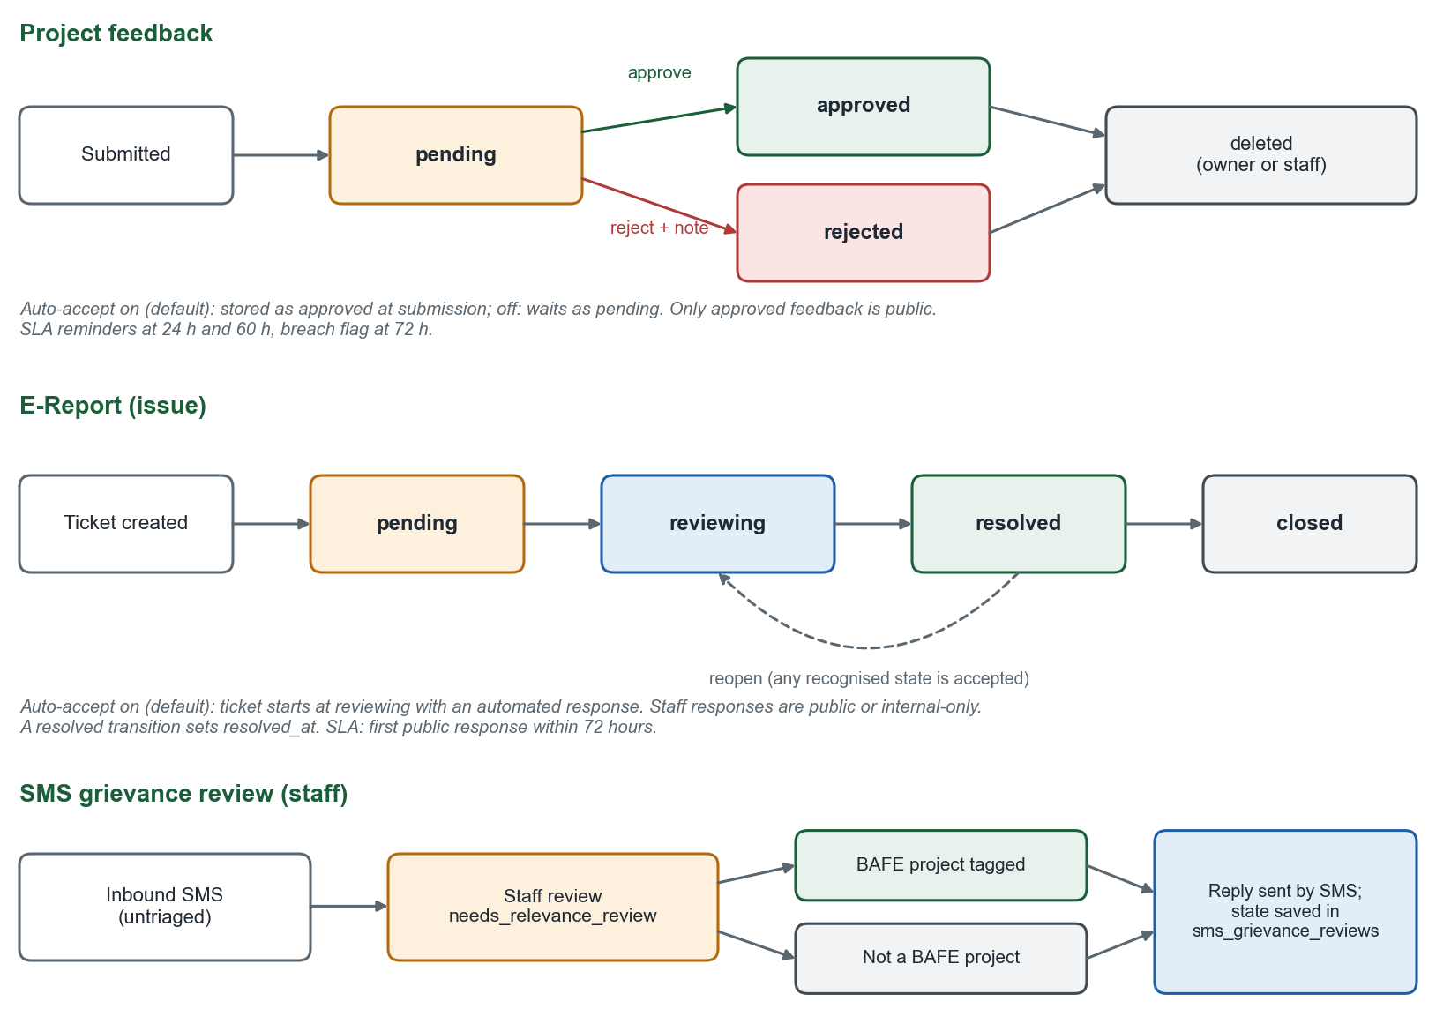
Figure 8. Feedback, E-Report, and SMS grievance states.

6.3 Feedback Workflow
From | To | Actor | Effect
(new) | approved | System, when auto-accept is on (default) | Citizen acknowledged; item public after automated checks
(new) | pending | System, when auto-accept is off | Waits for a moderator; SLA clock runs
pending | approved | Moderator in scope, regional admin, admin | Public; moderator and time stored; citizen notified
pending or approved | rejected | Same | Hidden from public; note shown to owner
any | deleted | Owner or staff | Row and attachments removed; audited

Comments carry their own status and an auto_rejected flag set by the profanity pre-check, and are reviewed on /comment-moderation.

6.4 E-Report Workflow
From | To | Actor | Effect
(new) | pending or reviewing | System (auto-accept setting) | Ticket created; staff notified; automated first response when auto-accept is on
pending | reviewing | Staff in scope | Handling started
reviewing | resolved | Staff in scope | resolved_at set; reporter notified
resolved | closed | Staff in scope | Final
any recognised state | any recognised state | Staff in scope | Allowed by the server; no enforced transition graph

Each response is public or internal-only, may carry attachments, and may change status and approve the public summary. Evidence images are approved individually for public display.

6.5 SLA Monitoring and Escalation
- Every 15 minutes the job selects open issues and pending feedback by age.
- At 24 hours: gentle reminder to the scoped moderators (checkpoint sla_gentle_reminder_at).
- At 60 hours: urgent reminder to moderators and administrators.
- After 72 hours: breach notice to administrators; the record is flagged in SLA reports.
- A real response (first non-internal issue response, or a moderation decision on feedback) ends the clock.

6.6 SMS Grievance Workflow
- Inbound message appears in the review list as untriaged.
- If the sender has an open case within a week, the auto-link job folds the message into it.
- If enabled, the auto-acknowledge job texts a first reply asking for project type, name, age, gender, and location (once per message).
- Staff tag an actual BAFE project, mark Not a BAFE project, or link a follow-up. The state is saved with a version check, then the SMS is sent.
- Replies are further SMS entries in the thread; internal notes stay internal.

6.7 Notification Workflow
- A domain event (new feedback, new E-Report, response, SLA checkpoint, ban, and so on) calls the notification service with a type, text, metadata, and the candidate recipients.
- The service filters recipients by scope and each user's channel preferences.
- One notifications row and the notification_recipients rows are written in a transaction.
- Connected users receive the event on their stream; notification-delivery jobs send email and SMS.
- The user opens the item; the read state is stored.

6.8 Knowledge Document Workflow
State | Meaning | Moves to
processing / indexing | Uploaded or entered; text being extracted, chunked, embedded | embedded or failed
embedded | Searchable by the assistant | archived; reindex keeps the old chunks until the new ones are ready
failed | Extraction or embedding failed; a sanitized reason is stored | Reindex
archived | Excluded from retrieval | Restored to active, or permanently deleted

6.9 Account and Live-Video States
- Account: unverified, verified (active), banned (optionally until ban_expires), deleted. Administrators move accounts between states with self-protection rules.
- Live video: inactive, scheduled (published in the future), live, featured, expired. A transaction guarantees at most one live and one featured entry at a time.

6.10 Design Constraints
- Staff transitions are limited by permission and scope, not by a transition graph (see limitation R-07).
- Auto-accept is a global setting; there is no per-region override.
- Workflow side effects (audit, notification) are separate writes and are not wrapped in one transaction with the state change.

7. Security Design

7.1 Overview
INFRA Watch handles citizen contact details, geotagged photographs, and staff decisions, and it publishes content under a government name. The design therefore focuses on controlling who can see and change what, keeping private evidence private, limiting what automated components can do, and recording what staff did.

7.2 Security Objectives
- Only authorized people can read private data or change records.
- Moderators see only the region and program they are assigned.
- Public output never exposes contact data, internal notes, or private evidence.
- Uploaded files cannot harm the system or other users.
- AI features cannot be steered to reveal internals or run harmful queries.
- Every staff action and security event is attributable.

7.3 Security Architecture Overview
Layer | Controls
Network and proxy | TLS (Let's Encrypt) at nginx; HTTP redirected; app bound to loopback; nginx replaces client-supplied X-Forwarded-For; chat endpoint unbuffered with a 65-second timeout; 110 MB body limit
Application edge | Trusted-origin list; origin check on staff mutations; JSON content-type and size checks; COOP and COEP headers
Identity | Better Auth sessions, email OTP, optional Google, bans, session revocation
Authorization | Role statements, moderator region and program scope, fail-closed defaults, admin-only operations
Data | Public DTOs, private bucket, hashed passwords, minimal analytics, retention limits
Content | Upload validation, NSFW checks, profanity screening, per-image public approval
AI | Bounded read-only tools, refusal policy, SQL guardrails, rate limits, history expiry
Monitoring | Audit log, sync logs, health check, failed-login and blocked-upload events

7.4 Authentication Design

7.4.1 Mechanism
Email and password (with required verification), email one-time codes, and optional Google sign-in. Passwords are hashed by Better Auth. Codes are 6 digits and expire after EMAIL_OTP_EXPIRY seconds (default 180). The OTP plugin cannot create accounts.

7.4.2 Session Management
Sessions are rows in session with expiry, IP address, and user agent and are carried in a cookie issued by Better Auth's Next.js plugin. Banning a user blocks new sessions; an administrator can end all sessions of a user. getSession is cached per request so repeated guard calls do not repeat database reads.

7.5 Authorization and Scope

7.5.1 Role, Resource, and Action Model
Statements in lib/permissions.ts list, for each resource, the allowed actions per role (see RAD Section 2.6 for the matrix). requirePermission throws a 403 error when the role lacks the action. The Better Auth admin plugin uses the same statements for its built-in operations.

7.5.2 Scope Resolution
- Determine the caller's role.
- If moderator: require at least one of region or program; if neither, deny everything (false condition).
- Add projects.region ILIKE region and projects.program = program as assigned.
- Always add the fiscal-year condition.
- For a single record (feedback, issue), call checkModeratorScope/checkIssueScope, which resolves the record's project and applies the same conditions; deny on mismatch.

7.6 Data Protection
- Public objects: public-issue-dto.ts and project/feedback DTOs include only fields marked public; media and geotags are sanitized.
- Private objects: issue evidence and knowledge-base files live in the private bucket and are streamed by authenticated handlers that re-check ownership or scope on every read.
- Anonymity: feedback marked anonymous is displayed without the author but keeps user_id for moderators; E-Reports marked anonymous store no name or contact data.
- Retention: short retention for chat history and snapshots; analytics events pruned; deletion pages describe the citizen's options.
- Secrets: database, auth, SMS, SMTP, storage, and AI credentials are environment variables only.
- Known gap: stored images keep EXIF metadata (R-05); recommended fix is metadata stripping for public media.

7.7 Upload Security
- Require a session; check the destination folder against an allowlist.
- Check declared MIME type, file extension, magic bytes, and size.
- Run NSFWJS on images and on sampled video frames (fail-closed available).
- Write only to an application-generated name (<timestamp>-<32 hex>.<ext>); never use the client file name as a path.
- Record blocked and NSFW-rejected uploads in audit_logs.
- Serve public media only from approved prefixes; serve private media through authorization checks.

7.8 Security for Inter-Service and External Interfaces
- ABEMIS: API key from the environment; fixed origin; redirects refused; retries bounded.
- KML proxy: size limit and URL checks to avoid server-side request abuse.
- SMS and SMTP: credentials server-side; failures returned as values without leaking provider detail.
- AI providers: only bounded, necessary context is sent; no raw user identity.
- Storage start-up check: refuse to run if the private bucket would allow anonymous reads.

7.9 AI Safety Design
Risk | Control
Prompt injection from retrieved data | Retrieved fields are labelled untrusted; tools return data only; injection phrases refused
Revealing internals or users | Policy refuses such requests; the model never sees raw identity; aggregate user counts only on the admin surface
Harmful generated SQL (MYDAS) | Single SELECT, keyword and table allowlists, row limit, 5-second timeout inside a transaction, admin only. Column access is controlled by the prompt, not by the validator
Cost and abuse | Request and history size limits, per-minute and daily limits, optional sign-in requirement
Wrong answers | Grounding in tools, verification notice on generated analysis, advisory wording

7.10 Security Monitoring and Auditing
The audit log records record changes, failed sign-ins, blocked and NSFW-rejected uploads, sync runs, and cache clears, with the actor, IP address, and user agent. Staff review it in /audit-logs. Sync history and job progress show operational anomalies. The service health page shows database, object storage, and Redis status.

7.11 Privacy and Compliance (RA 10173)
Principle | Design response
Transparency | Privacy notice, terms of service, and data deletion pages
Legitimate purpose and proportionality | Only fields needed for handling a report are collected; survey is optional
Security | Controls in this chapter
Data subject rights | Staff can delete a submission or an account; owners can edit and delete their own feedback
Retention | Limits in Section 4.9 and RAD Section 4.7

7.12 Security Headers and Browser Protections
- Cross-Origin-Opener-Policy: same-origin and Cross-Origin-Embedder-Policy: credentialless on all responses.
- Secure and SameSite cookie attributes in production through Better Auth.
- Strict image sources in next.config.ts (own origin, the object-storage host, Google avatar host, ABEMIS host, and local MinIO in development).
- Recommended addition: a Content-Security-Policy and Strict-Transport-Security header at nginx; neither is set in the sample configuration.

7.13 Summary of Controls and Known Gaps
Area | Status | Note
Role and scope enforcement | Implemented | Fail-closed for moderators
Private evidence | Implemented | Bucket policy reconciliation at start-up
Upload validation and NSFW check | Implemented | Fail-closed optional
Audit log | Implemented | No automatic purge
Direct plugin administration limit | Confirm | Review finding S1
Dependency advisories | Confirm | Review finding S2; audit in CI
EXIF stripping | Not implemented | R-05
Knowledge-base visibility state | Not implemented | R-06
CSP and HSTS headers | Not configured | Recommend at nginx

8. Error Handling and Logging

8.1 Objectives
- Tell users what they can fix and nothing more.
- Never expose stack traces, SQL, file paths, or credentials.
- Keep enough information in logs and the audit table to diagnose and to account for actions.
- Make background failures visible and retryable.

8.2 Error Taxonomy
Class | HTTP | Examples | Handling
Validation | 400 | Missing comment; coordinates out of range; unsupported media | Message returned; no write
Authentication | 401 | No session | Redirect to sign-in or JSON error
Authorization | 403 | Citizen on staff route; out-of-scope record; cross-origin mutation | Denied; sensitive denials audited where relevant
Not found | 404 | Unknown project, issue, or view | Generic message
Payload | 413, 415 | Body too large; wrong content type | Rejected before parsing
Method | 405 | Data-quality project PATCH | Deliberate, with explanation
Dependency | 503 | Project data temporarily unavailable (public analytics) | Generic message; logged by name
Internal | 500 | Unexpected exception | "Service unavailable. Try again."; logged

8.3 Client Error Messages
Staff APIs return { "error": "..." }. Participation APIs return { "success": false, "error": "..." }. Upload errors are mapped to friendly text by getClientUploadErrorMessage. AI endpoints return a single generic error message for failures. Interfaces show unavailable, unknown, stale, and cannot-be-assessed states in plain words rather than blank values.

8.4 Logging Design
Log | Content | Where
Application log | Operational events and server error names; scheduler and sync progress; no secrets or personal data | Container stdout (Docker logs), plus .dev-logs in development
Audit log | Business and security events with actor, old and new values, IP address, user agent | audit_logs table; /audit-logs
Sync log | Per-run counts, errors, duration, trigger | sync_logs; /sync
Job state | Status, attempts, progress, result, error | background_jobs; /api/admin/jobs
Chat history | Turn text, provider, model, tools used, tokens, duration, status | ai_chat_history (expiring)
Web analytics | Page usage when consented | Google Analytics 4 (optional)

8.5 Audit Entries
An audit row has: table_name, record_id, action (for example CREATE, UPDATE, DELETE, or a named event), user_id, user_name, old_values, new_values, changed_fields, ip_address, user_agent, notes, created_at. Staff mutations call logAudit with a context built by getAuditContextFromRequest so IP and user agent are included.

8.6 Failure Handling by Component
Component | On failure | Recovery
ABEMIS sync | Run marked failed or completed with warnings; counts and error details stored | Next scheduled tick; manual run; retry from /api/admin/jobs
Background job | Attempts incremented; retried with back-off up to the maximum; then failed | Admin retry (PATCH /api/admin/jobs)
SMS send | Decision already saved; thread entry marked failed | Staff resend from the Reply tab
Email | Returns an error value; delivery job retried | Fix SMTP settings; retry
MinIO | Upload error to the user (or local fallback in code, see R-04) | Restore storage; reconcile on restart
Redis | Ignored; memory cache continues; retry after 30 seconds | None needed
AI provider | Generic error; history marked failed | Retry; switch provider by configuration
Database | Requests fail; container health depends on it | Restore database; start-up waits up to 30 attempts

8.7 Monitoring and Alerting Recommendations
- Alert when no successful sync has completed in 24 hours.
- Alert on a growing number of failed jobs or repeated failed sign-ins.
- Watch MinIO and PostgreSQL disk and backup status.
- Review SLA breach counts weekly.
- Collect container logs centrally and keep them separate from the audit table, which is for accountability rather than diagnostics.

8.8 Example Scenarios

Scenario A: ABEMIS returns HTTP 526 at the scheduled hour
The client retries three times and the run is logged as failed with the error text. No project data changes. Three hours later the schedule tries again; the last-sync time on public pages shows the data's true age until a run succeeds.

Scenario B: a citizen uploads a renamed executable as a photo
The signature check does not match the declared image type, so the upload is rejected with a validation error, nothing is stored, and an audit entry records the blocked file name, type, and size.

Scenario C: two reviewers reply to the same SMS
Both load version 3 of the review. The first save becomes version 4 and the SMS is sent. The second save sees a version mismatch and is rejected, so the sender receives one reply.

9. Deployment Design

9.1 Topology
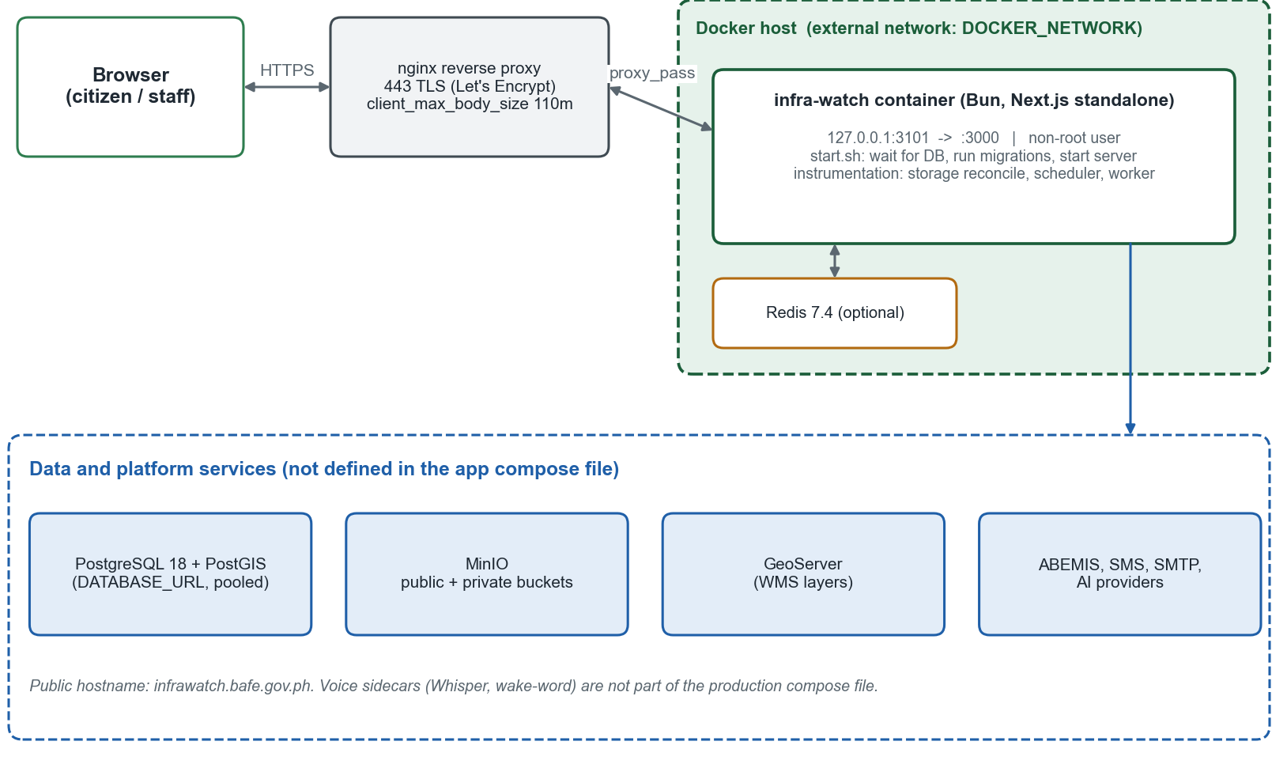
Figure 9. Deployment topology.

9.2 Build and Container
Stage | What it does
dependencies | bun install --frozen-lockfile on oven/bun:1.3.14-slim; preloads the GeoIP database
builder | Copies sources; passes public build arguments (NEXT_PUBLIC_APP_URL, NEXT_PUBLIC_MINIO_*, NEXT_PUBLIC_GEOSERVER_*, NEXT_PUBLIC_GA_MEASUREMENT_ID); runs bun run build with placeholder database and auth values
runner | Creates a non-root user; installs ffmpeg; copies the standalone output, static files, lib, migrations, scripts, and docker/start.sh; the container command /app/start.sh waits for PostgreSQL, applies migrations, then runs bun server.js; the image has a 30-second HTTP health check on port 3000

Public build arguments are inlined into the client bundle, so changing the public URL, bucket host, GeoServer URL, or analytics ID requires a rebuild.

9.3 Compose and Reverse Proxy
- docker-compose.production.yml defines the app service (restart unless-stopped, init: true, port 127.0.0.1:${APP_PORT:-3101}:3000, environment from .env.production) and an optional cache service (Redis 7.4, append-only, 256 MB, LRU eviction) behind the cache profile. It joins an external Docker network (DOCKER_NETWORK).
- deploy/nginx/infrawatch.bafe.gov.ph.conf redirects HTTP to HTTPS, serves the ACME challenge, terminates TLS, sets client_max_body_size 110m, proxies /api/chat with buffering off and a 65-second timeout, and proxies everything else with upgrade support and 300-second timeouts. It replaces, rather than appends to, client-supplied forwarding headers.

9.4 Start-Up Sequence
- /app/start.sh (from docker/start.sh) waits for PostgreSQL (up to 30 attempts, 2 seconds apart).
- If RUN_DB_MIGRATIONS is not false: scripts/prepare-migrations.ts, then scripts/migrate.mjs.
- bun server.js starts the standalone Next.js server as the non-root user.
- instrumentation.ts (Node runtime, production): ensureStorageBuckets reconciles public and private bucket policies and aborts on a collision or unsafe policy; then the scheduler starts, then the background worker.

9.5 Configuration
All configuration is by environment variables (Appendix A). Production requires DATABASE_URL, BETTER_AUTH_SECRET, and BETTER_AUTH_URL; optional groups (SMS, AI, voice, Redis, analytics) switch features on or off. Secrets belong in .env.production on the host or a secret store and never in the repository.

9.6 Release Checklist
Step | Command or action
Type check | bunx tsc --noEmit
Lint | bun run lint --quiet
Tests | bun test --timeout 30000
Build | bun run build
Diff hygiene | git diff --check
Visual review | Check new pages at desktop and phone widths
Environment | Confirm secrets, bucket names, and public build arguments
Database | Back up before migrating; review new migration files
Storage | Verify both bucket policies and a real upload in the target environment
After deploy | Open /health-check; trigger a sync; confirm last-sync time updates

9.7 Backup and Recovery
- Back up PostgreSQL on a schedule and test restores; the projects read model can be rebuilt from ABEMIS, but engagement data and audit logs cannot.
- Back up both MinIO buckets; evidence is not recoverable from other sources.
- Keep .env.production secrets in a secure store.
- Use docs/migrations/*-rollback.sql for the migrations that have prepared rollbacks.

10. Quality and Testing Design

10.1 Test Layers
Layer | What is covered | Tooling
Unit and policy tests | About 230 test files beside the code: permissions, scope, year scope, stage mapping, transforms, upload policy, chat policy and limits, SQL guardrails, SLA logic, DTO output, analytics queries, parsers | bun test
Handler tests | Route handlers built with injectable dependencies (notifications, upload preview, chat) so authorization and error paths can be tested without a server | bun test
Static checks | Type safety and lint rules | tsc --noEmit, ESLint
Build check | Production build with standalone output | bun run build
Manual and browser review | Responsive layout, accessibility, map and chart behavior, real upload against the target storage | Release checklist

This document did not re-run the test suite. The security review of 27 September 2026 recorded a passing type check, most tests passing, and a small number of lint errors and test failures at that time; run the checklist before each release.

10.2 Design for Testability
- Pure functions hold rules (scope conditions, status mapping, SLA thresholds, banner parsing) so they can be tested without a database.
- Route handlers receive their dependencies as arguments, which allows tests to supply fakes.
- Constants (SLA hours, limits) live in one module and are shared by code and reports, so tests and behavior cannot drift apart.

10.3 Acceptance
Acceptance criteria for each requirement are in the RAD traceability matrix (RAD Section 8.3). A release is accepted when the checklist in Section 9.6 passes and the criteria for changed requirements are demonstrated.

11. Appendices

Appendix A. Environment Variable Reference
Names only; values are secrets or deployment-specific. Variables prefixed NEXT_PUBLIC_ are inlined at build time.
Group | Variables
Database | DATABASE_URL, DATABASE_POOL_MAX, DATABASE_IDLE_TIMEOUT, DATABASE_MAX_LIFETIME, RUN_DB_MIGRATIONS, BASELINE_EXISTING_DATABASE, DRIZZLE_INCLUDE_AUTH
Authentication | BETTER_AUTH_SECRET, BETTER_AUTH_URL, GOOGLE_CLIENT_ID, GOOGLE_CLIENT_SECRET, EMAIL_OTP_EXPIRY, ADMIN_EMAIL, ADMIN_EMAILS, ADMIN_NAME, ADMIN_PASSWORD
Application | NEXT_PUBLIC_APP_URL, NEXT_PUBLIC_BASE_URL, APP_PORT, DOCKER_NETWORK, ENABLE_SCHEDULER, ENABLE_BACKGROUND_WORKER
ABEMIS and sync | ABEMIS_BASE_URL, ABEMIS_API_KEY, ABEMIS_INFRA_ENDPOINT, SYNC_CRON_SCHEDULE
Object storage | MINIO_ENDPOINT, MINIO_PORT, MINIO_USE_SSL, MINIO_ACCESS_KEY, MINIO_SECRET_KEY, MINIO_BUCKET_NAME, MINIO_PRIVATE_BUCKET_NAME, NEXT_PUBLIC_MINIO_ENDPOINT, NEXT_PUBLIC_MINIO_BUCKET, NEXT_PUBLIC_MINIO_USE_SSL
Uploads and moderation | ALLOWED_IMAGE_TYPES, ALLOWED_VIDEO_TYPES, MAX_IMAGE_SIZE, MAX_VIDEO_SIZE, NSFW_IMAGE_MODERATION_ENABLED, NSFW_FAIL_CLOSED, NSFW_PORN_THRESHOLD, NSFW_HENTAI_THRESHOLD, NSFW_SEXY_THRESHOLD, FFMPEG_PATH, FFPROBE_PATH
Email | MAIL_HOST, MAIL_PORT, MAIL_USERNAME, MAIL_PASSWORD, MAIL_ENCRYPTION, MAIL_FROM_ADDRESS, MAIL_FROM_NAME
SMS | SMS_API_URL, SMS_SENDER_ID, SMS_USERNAME, SMS_PASSWORD, SMS_GRIEVANCE_API_URL, SMS_AUTO_ACK_ENABLED, SMS_AUTO_ACK_SINCE
AI | AI_PROVIDER, AI_MODEL, GEMINI_API_KEY, GOOGLE_GENERATIVE_AI_API_KEY, OPENAI_API_KEY, ANTHROPIC_API_KEY, KIMI_API_KEY, ENABLE_MANAGERIAL_AI
Assistant limits | CHAT_REQUIRE_AUTH, CHAT_RATE_LIMIT_PER_MINUTE, CHAT_GLOBAL_DAILY_LIMIT, CHAT_HISTORY_RETENTION_DAYS, CHAT_RESPONSE_TIMEOUT_MS, CHAT_TRUST_PROXY, CHAT_RATE_LIMIT_SECRET
Knowledge base | KB_CHUNK_SIZE, KB_CHUNK_OVERLAP
Voice | VOICE_ASSISTANT_ENABLED, WAKE_WORD, WAKE_WORD_MODEL_PATH, WAKE_WORD_THRESHOLD, WAKE_WORD_TOKEN_SECRET, WAKE_WORD_WS_URL, SLEEP_WORD_MODEL_PATH, LOCAL_WHISPER_URL, LOCAL_WHISPER_TOKEN, KOKORO_MODEL_PATH, KOKORO_VOICE
Cache and analytics | REDIS_URL, NEXT_PUBLIC_GA_MEASUREMENT_ID, ANALYTICS_PROXY_SECRET, ANALYTICS_TRUST_PROXY_HEADERS
Maps | NEXT_PUBLIC_GEOSERVER_URL, NEXT_PUBLIC_GEOSERVER_WORKSPACE

Appendix B. Table Catalog
Generated from the live schema on the document date: column and secondary-index counts per table.
Table | Columns | Indexes | Purpose
account | 13 | 0 | Credential and OAuth links
account_preferences | 5 | 0 | Notification channel choices
ai_chat_history | 20 | 6 | Assistant conversation turns
ai_chat_rate_limits | 4 | 1 | Assistant request windows
analytics_daily_aggregates | 9 | 2 | Daily usage rollups
analytics_events | 9 | 3 | Minimal usage events
announcements | 9 | 0 | Dated announcements
articles | 15 | 1 | News and updates
audit_logs | 13 | 4 | Audit trail
background_jobs | 16 | 2 | Job queue
contact_messages | 12 | 3 | Contact and suggestions
contact_responses | 7 | 1 | Replies to contact messages
email_templates | 11 | 0 | Editable emails
feedback | 21 | 3 | Project feedback
feedback_comment_votes | 5 | 1 | Comment votes
feedback_comments | 15 | 3 | Comments on feedback
issue_responses | 13 | 2 | Staff responses to E-Reports
issues | 35 | 3 | E-Reports
kb_chunks | 7 | 2 | Knowledge chunks and embeddings
kb_documents | 20 | 5 | Knowledge documents and FAQs
live_videos | 21 | 2 | Broadcast entries
map_layers | 15 | 0 | GeoServer layer definitions
mydas_dashboards | 6 | 1 | Saved MYDAS dashboards
notification_reads | 4 | 2 | Read receipts
notification_recipients | 4 | 3 | Per-user notifications
notifications | 6 | 1 | Notification events
post_subscriptions | 6 | 2 | Post follow subscriptions
project_commodity_overrides | 6 | 0 | Commodity overrides
project_data_corrections | 9 | 2 | Recorded corrections
project_metric_snapshots | 18 | 4 | Daily project snapshots
projects | 57 | 5 | ABEMIS project read model
psgc_locations | 28 | 0 | PSGC reference data
regional_statistics | 17 | 1 | Regional statistics
saved_posts | 5 | 2 | Bookmarks
session | 9 | 0 | Sessions
sms_grievance_reviews | 6 | 1 | SMS review state
spatial_ref_sys | 5 | 0 | PostGIS reference
submission_surveys | 11 | 4 | Optional surveys
sync_logs | 15 | 0 | Sync run history
system_settings | 6 | 0 | Key-value settings
upload_sessions | 10 | 1 | Resumable uploads
user | 14 | 0 | Accounts and roles
user_tour_progress | 4 | 0 | Guided tour progress
verification | 6 | 0 | One-time codes

Appendix C. Glossary
Term | Meaning
Read model | A copy of source data kept for fast, safe reading
Scope | Region and program assignment that limits a moderator's view
Public DTO | A purpose-built object that contains only fields safe to show publicly
Auto-accept | System setting that publishes feedback and starts issues at reviewing after automated checks
Lease | A time-limited claim on a background job that lets another worker take over if the first stops
Dedupe key | Value that prevents two active jobs of the same kind
ANIA | The INFRA Watch AI assistant
MYDAS | Natural-language dashboard designer for administrators

Appendix D. Change History and Document Control
Version | Date | Author | Description
1.0 | October 2026 | INFRA Watch Project Team | First formal SDD, written from the implemented system and verified against the repository.

Item | Detail
Document | Software Design Document (SDD), INFRA Watch
Version and date | 1.0, October 2026
Prepared by | INFRA Watch Project Team
Institution | Department of Agriculture - Bureau of Agricultural and Fisheries Engineering (DA-BAFE)
Companion document | Requirements Analysis Document (RAD), INFRA Watch
Review and approval | Reviewed by: ____________________ Approved by: ____________________ Date: ____________

